**Continuous Integration with Jenkins**

**Problem Statement**

Whenever developers write code and merge it into the central repository, at the end of the day or week, we often end up with numerous untested and undeployed commits. This leads to a significant issue: during deployment, developers frequently encounter bugs, causing overhead and delays. This situation becomes even more critical when deadlines are near or already passed.

**Solution**

**Continuous Integration**

Continuous Integration (CI) is the practice of automatically building and testing code changes frequently. Every time code is committed to the repository, it should be fetched, built, and tested. If any bugs are detected, developers should be notified immediately. This approach ensures that code is continuously integrated and tested, reducing the likelihood of encountering bugs at deployment time.

However, manually performing these tasks can be daunting and error-prone. The solution lies in automating the process using a tool called Jenkins.

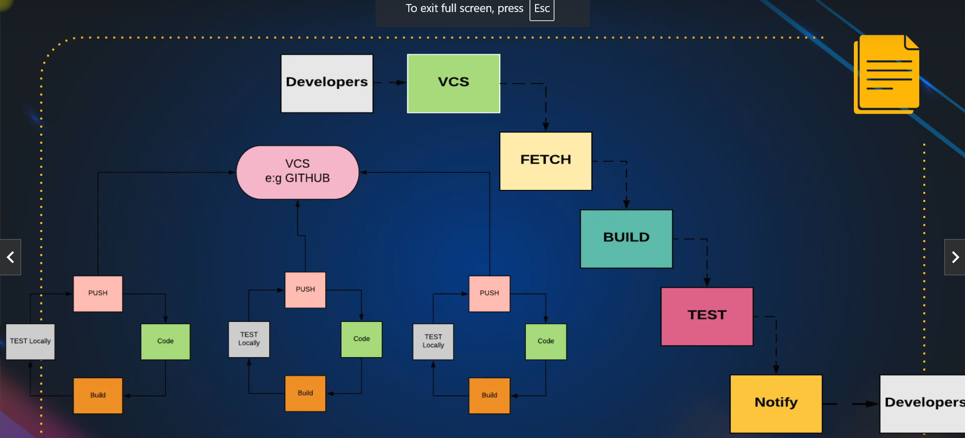

**Continuous Integration with Jenkins**

Jenkins is one of the most famous tools for Continuous Integration. It automates the process of building, testing, and deploying code changes, making it an invaluable asset for developers.

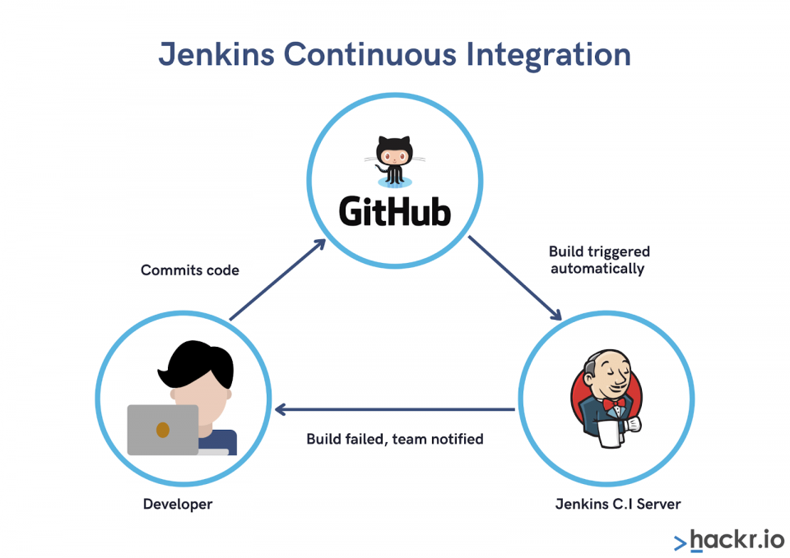

**Features of Jenkins**

* **Open Source**: Jenkins is an open-source tool, which means that developers from various regions are continuously contributing to its enhancements and making it better.
* **Extensible**: Jenkins is highly extensible through plugins. Some of the essential plugins include:
  + **VCS (Version Control System) Plugin**: Integrates Jenkins with version control systems like Git, allowing Jenkins to fetch code changes from the repository.
  + **Build Plugin**: Automates the build process, compiling the code and preparing it for testing and deployment.
  + **Cloud Plugin**: Integrates Jenkins with cloud services, enabling scalable and flexible CI/CD pipelines.
  + **Testing Plugin**: Automates the testing process, running tests on the code to ensure it is free from bugs and issues.

**How Jenkins Automates CI**

1. **Code Fetching**: Jenkins fetches the latest code changes from the central repository whenever a commit is made.
2. **Building**: The build plugin compiles the fetched code, creating an executable or deployable artifact.
3. **Testing**: The testing plugin runs automated tests on the built code to detect any bugs or issues.
4. **Notification**: If any bugs are found during testing, Jenkins immediately notifies the developers, allowing them to address the issues promptly.

By automating these steps, Jenkins ensures that code is continuously integrated and tested, reducing the overhead and delays caused by manual processes.

**How to install Jenkins**

Let us launch an ec2 instance and install Jenkins on that.

First go to installation of Jenkins with the help of documentation

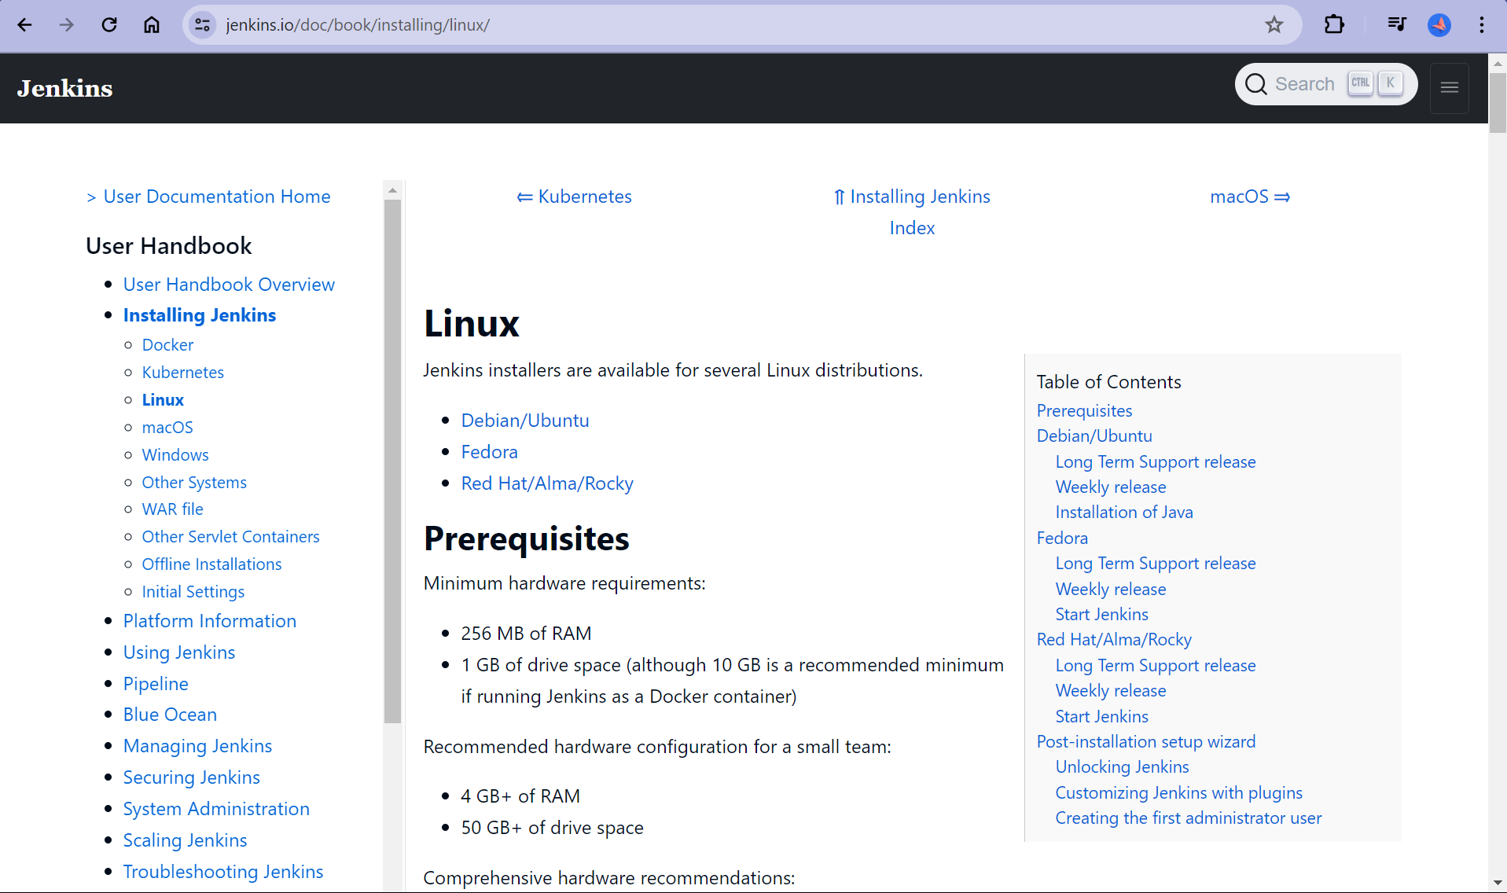

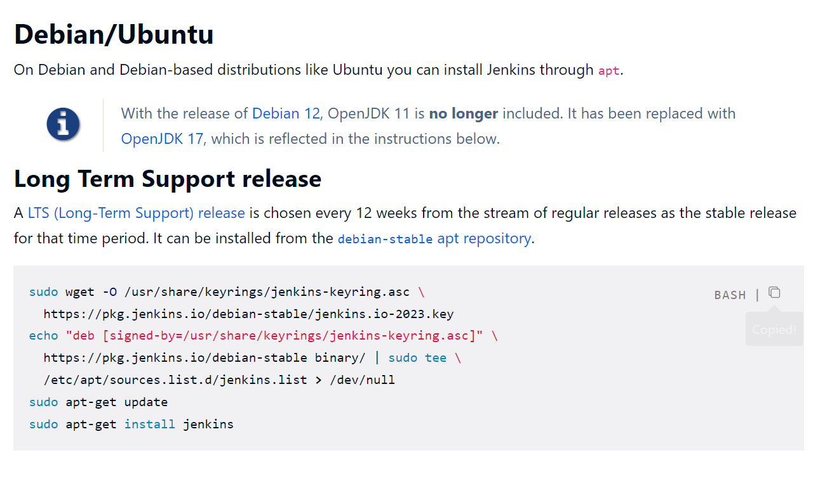

Run all commands after SSH and install Jenkins

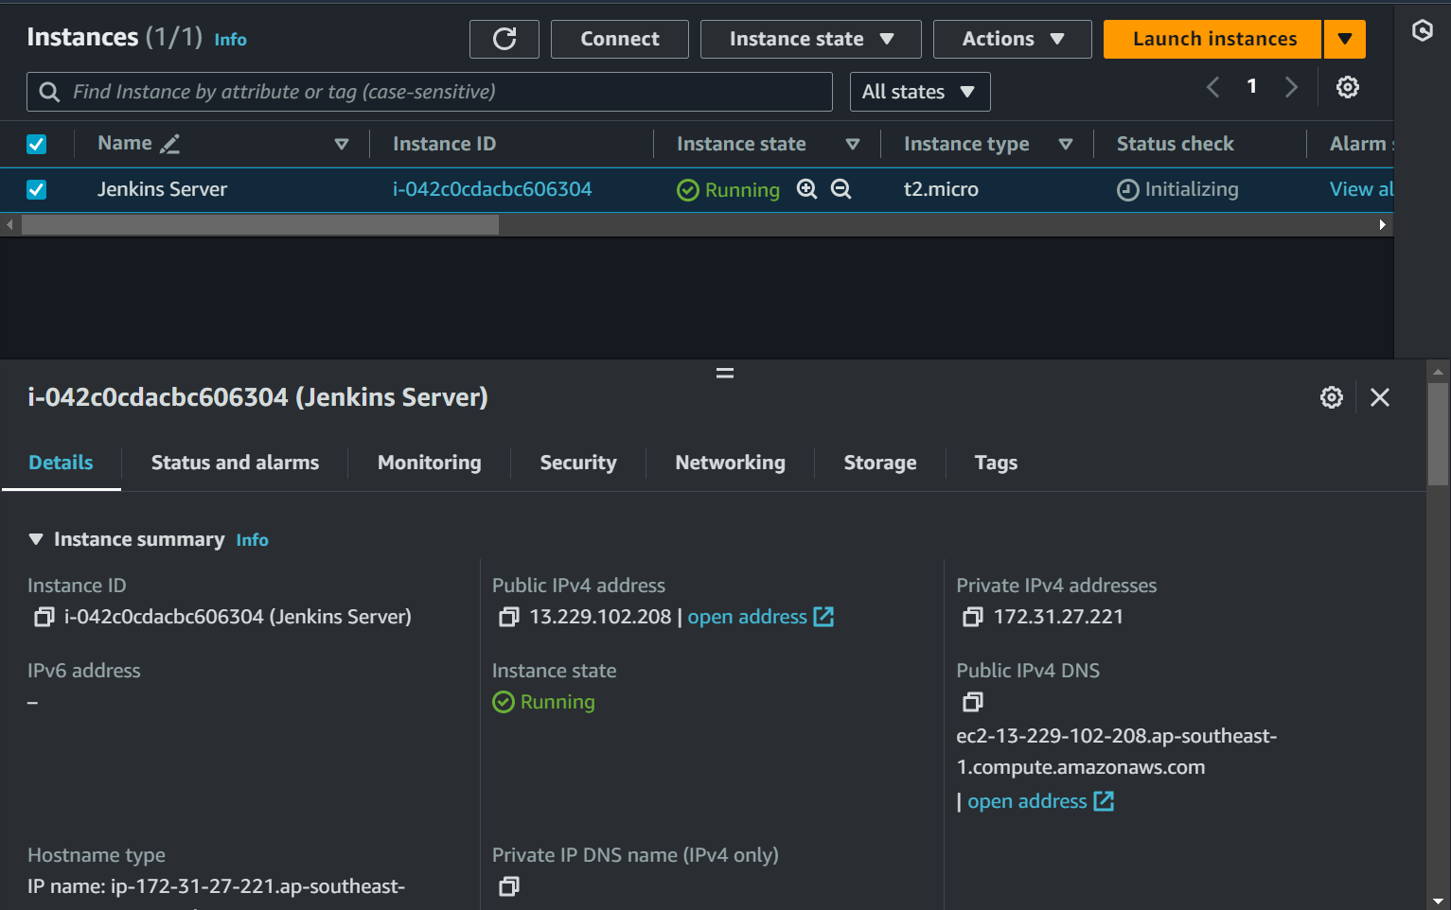

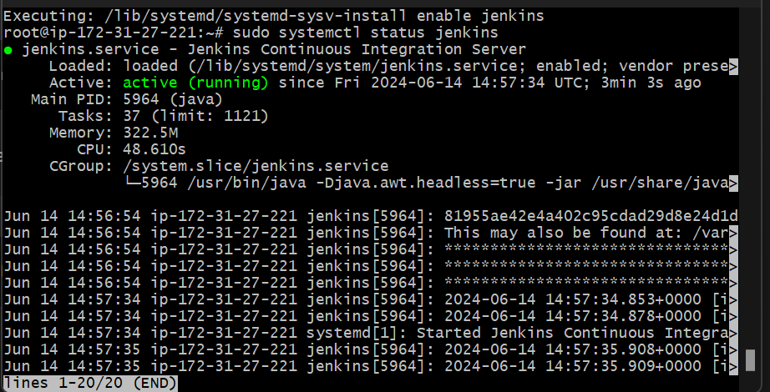

All Data is stored in home directory of Jenkins

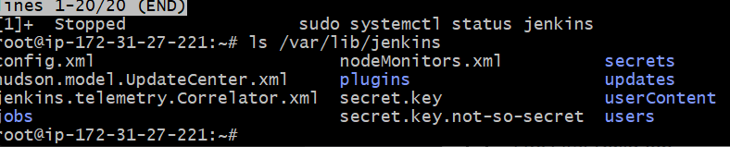

There is a user called Jenkins which run jenkins service

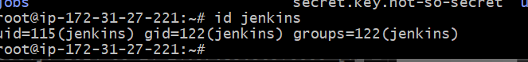

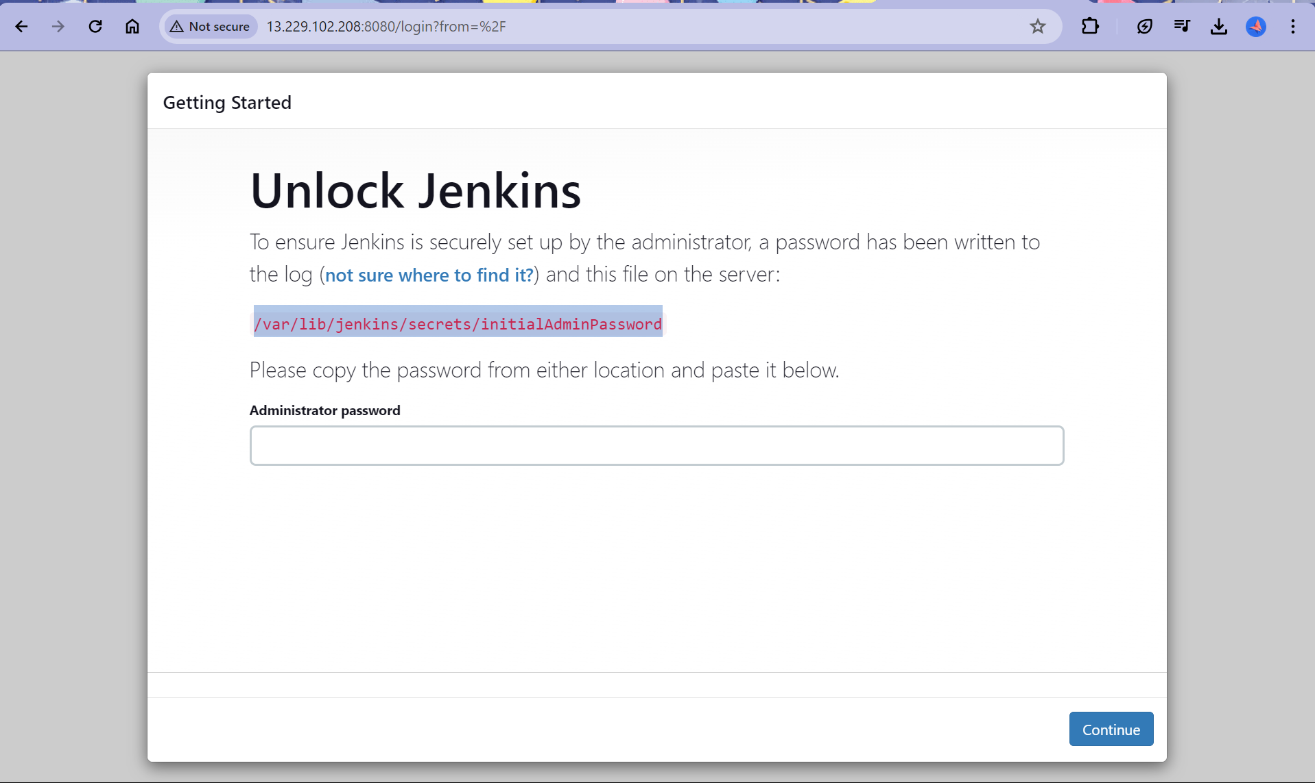

Go to file path and get initial login password



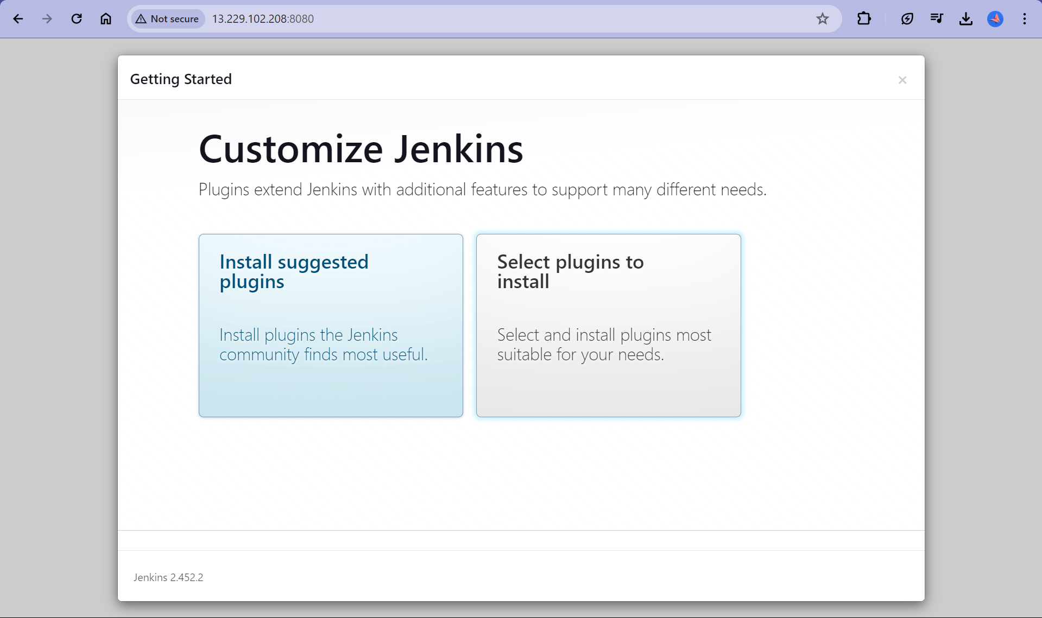

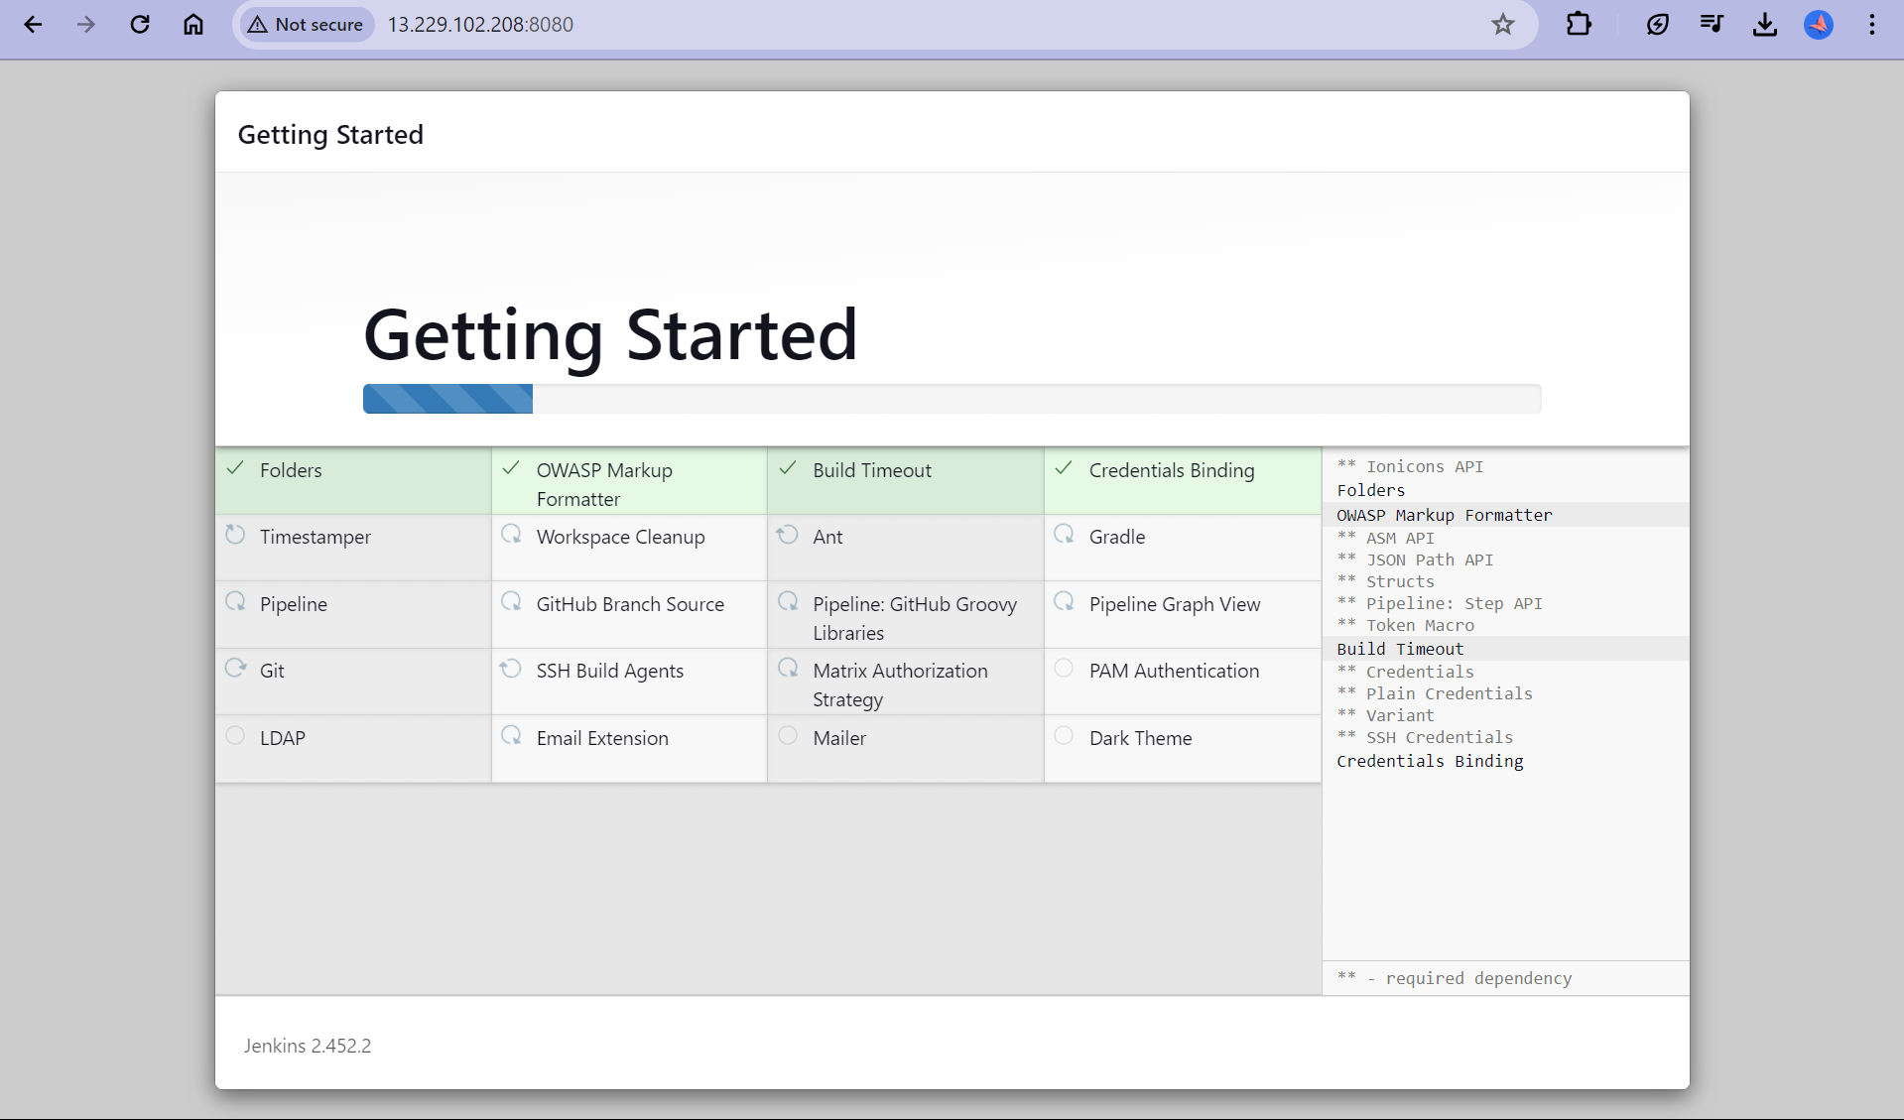

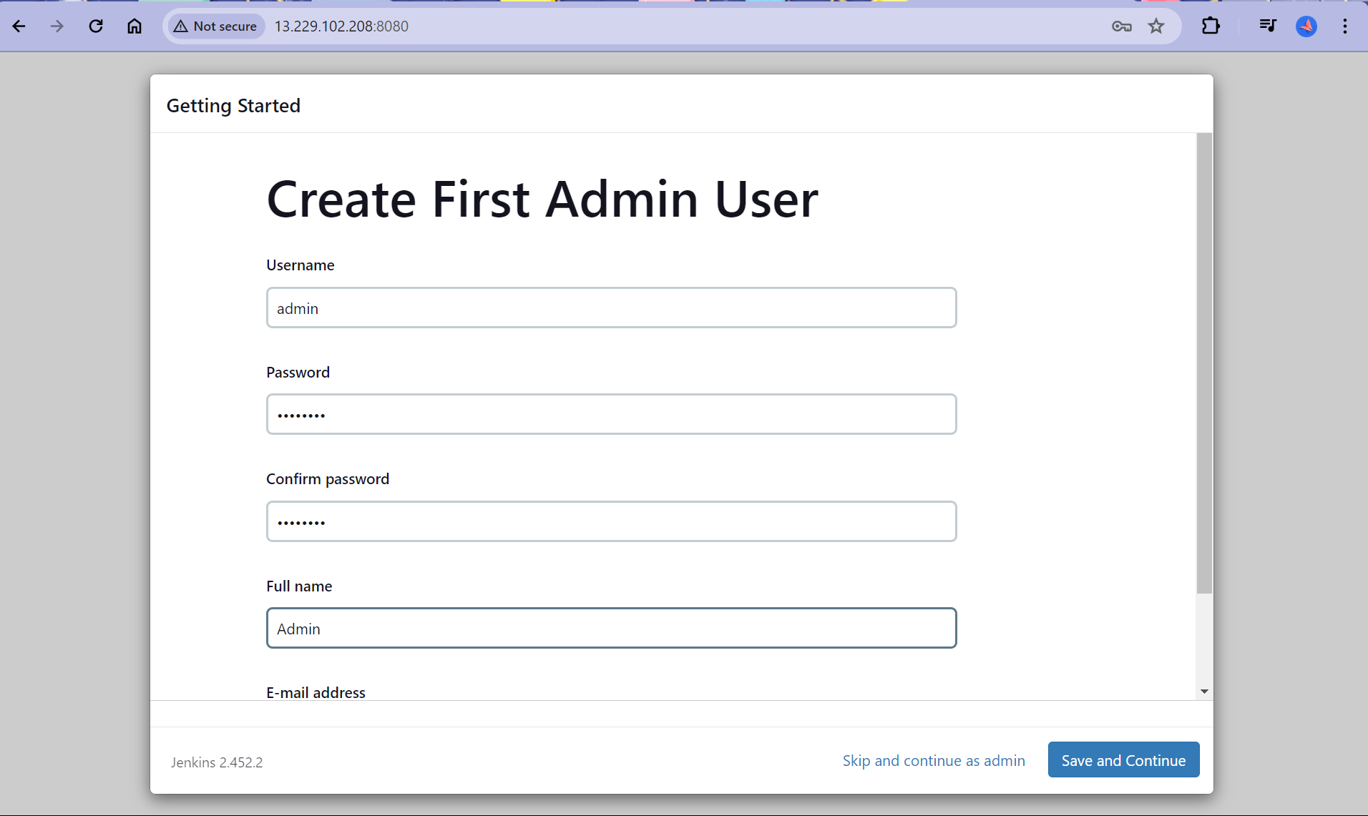

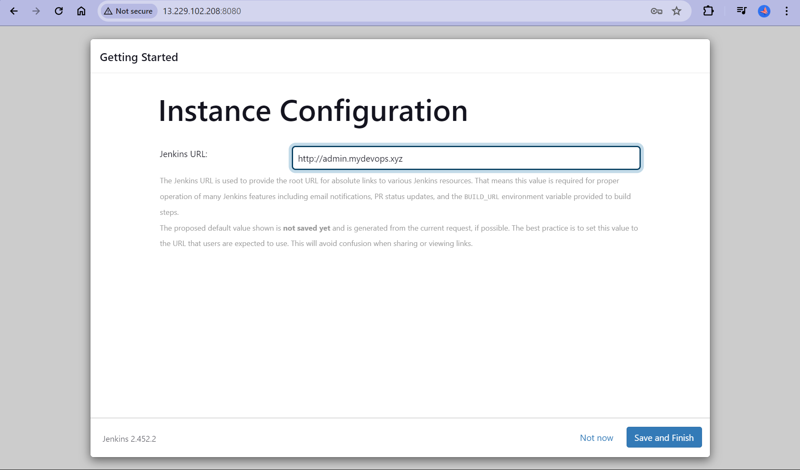

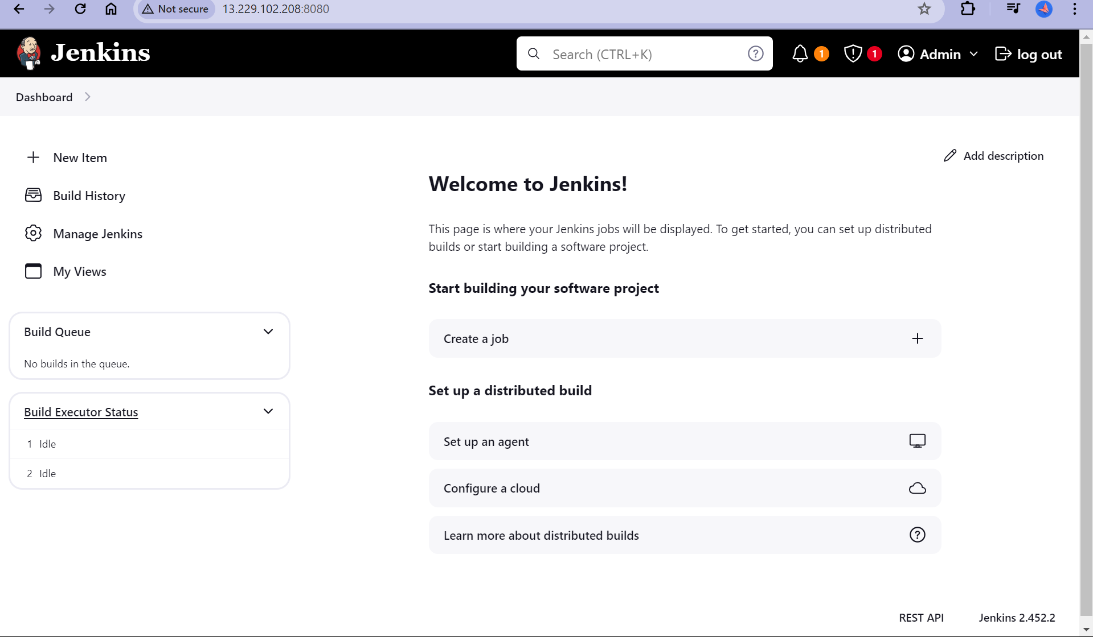

**Jobs in Jenkins**

There are 2 types of jobs in Jenkins:- Freestyle and Pipeline as code.

Jobs basically means workload which Jenkins runs for you.

Freestyle:-

* + - Graphical Jobs.
    - Learning, exploring and understanding Jenkins.
    - Not recommended, because you have to 1000s of click manually.

Pipeline as code:-

* + - Pipeline created in Groovy.
    - Recommended now.

**Creating Jobs in Jenkins**

Now we will create a job in Jenkins that will fetch our source code and build that source code using mvn command.

In Jenkins always remember 2 things you need Tools and Plugins.

**Getting tools:**

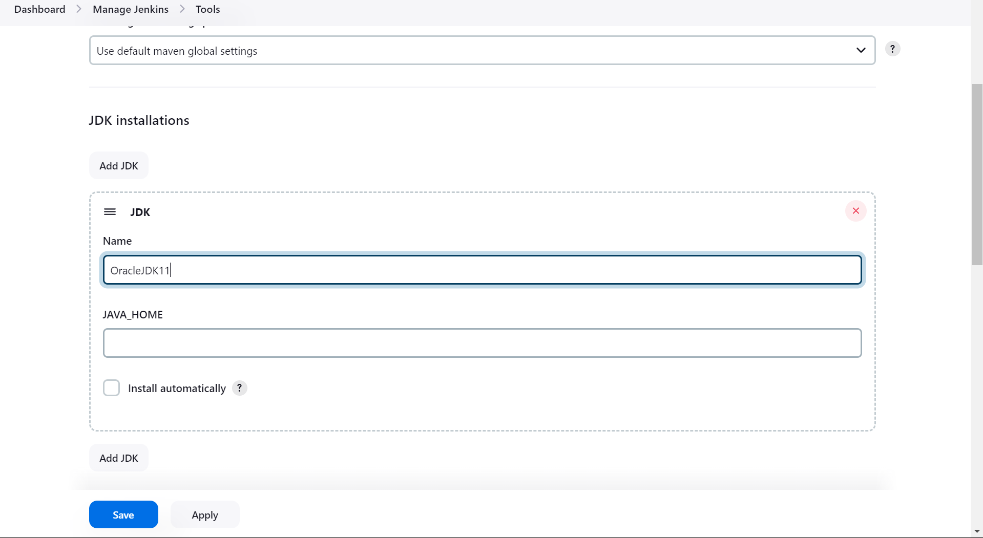

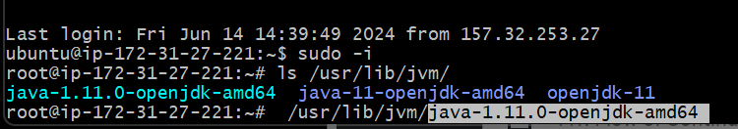

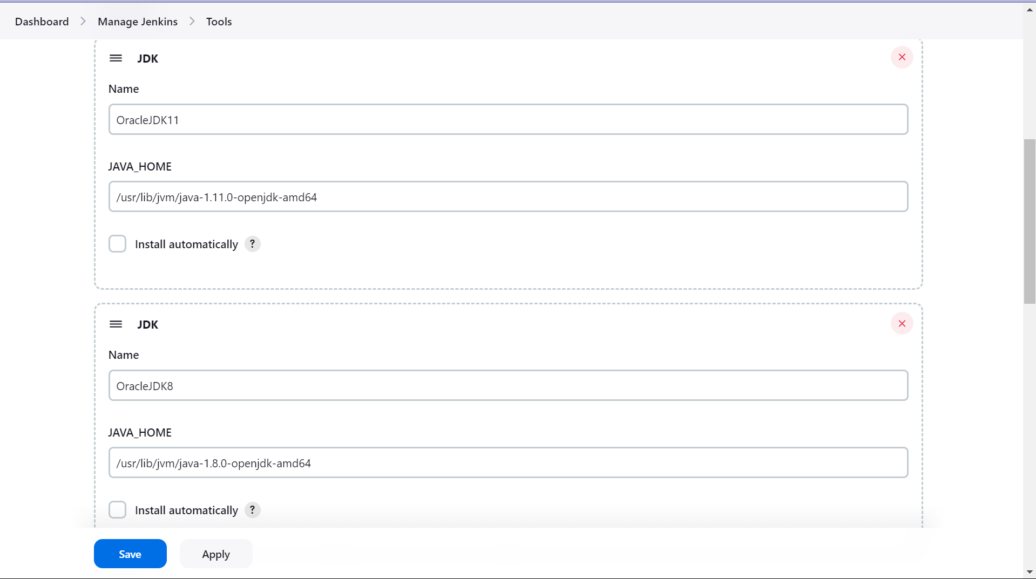

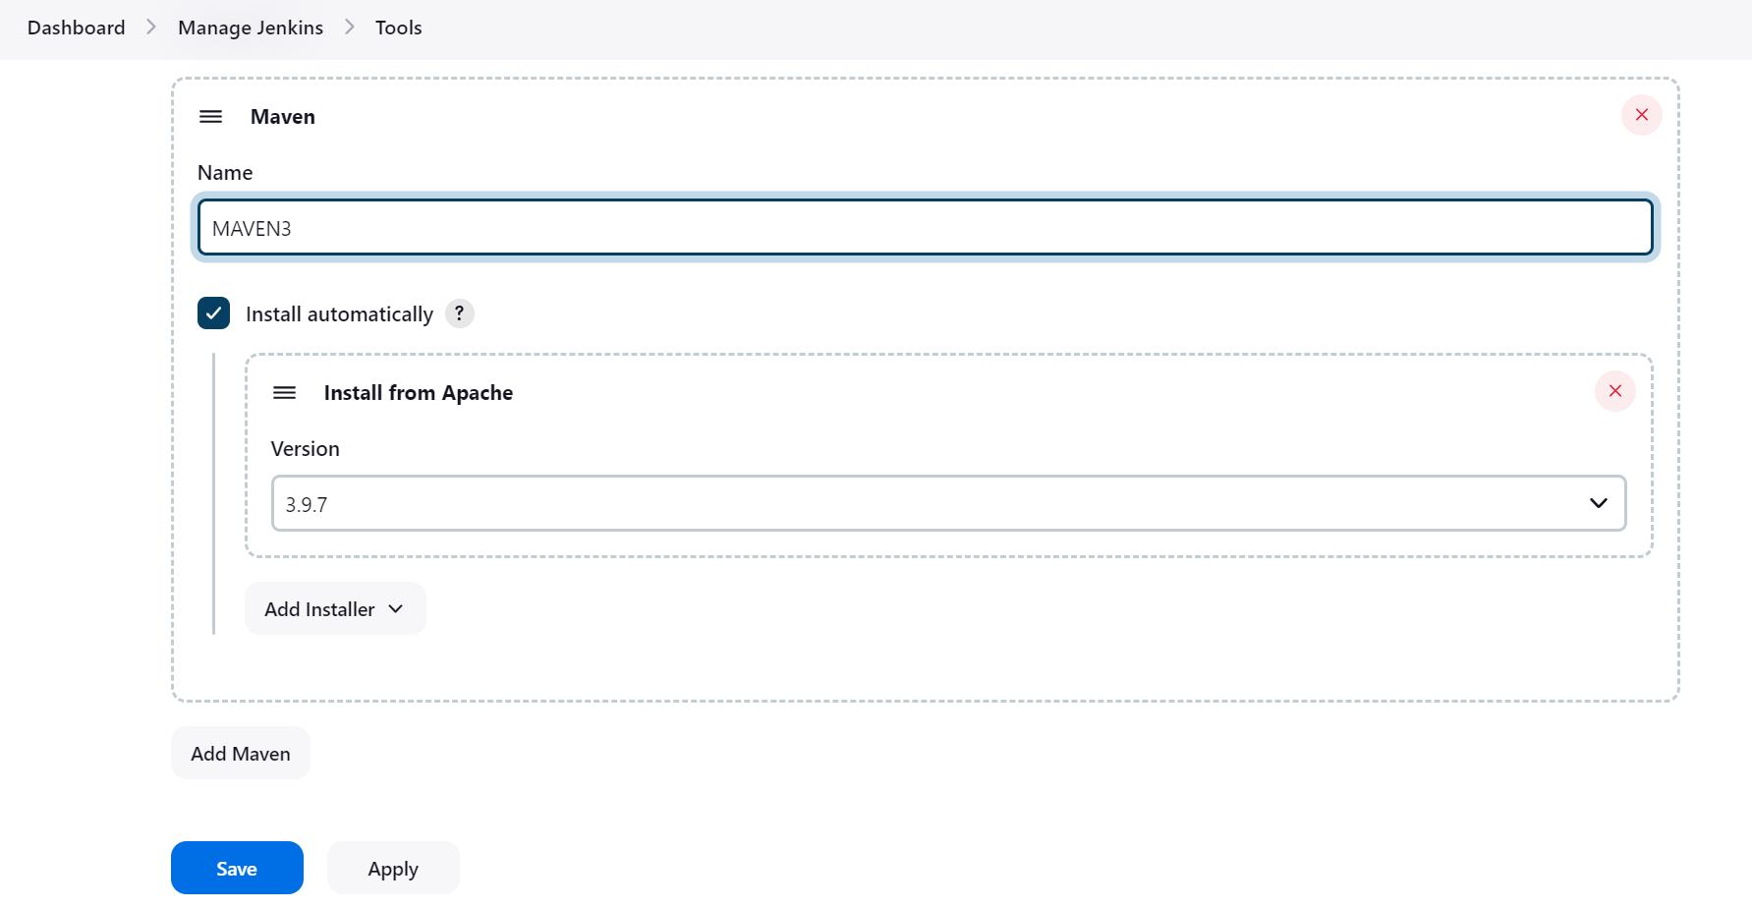

**First Job: Freestyle Project**

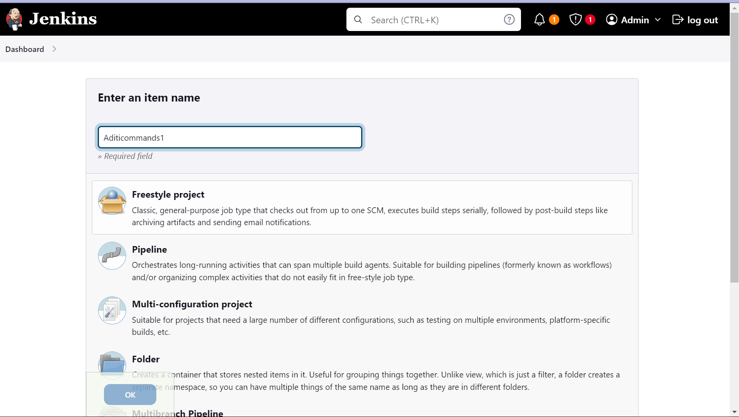

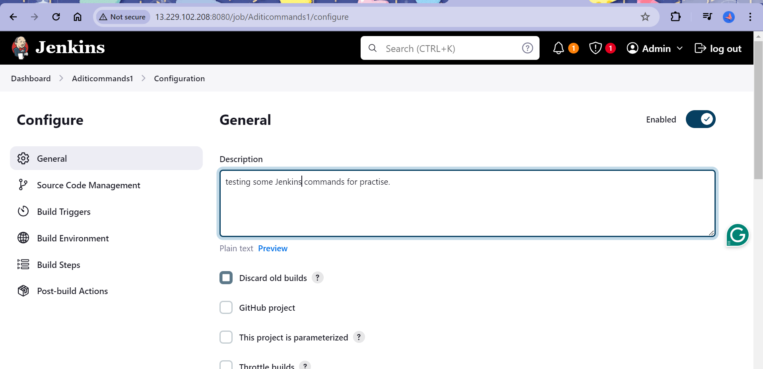

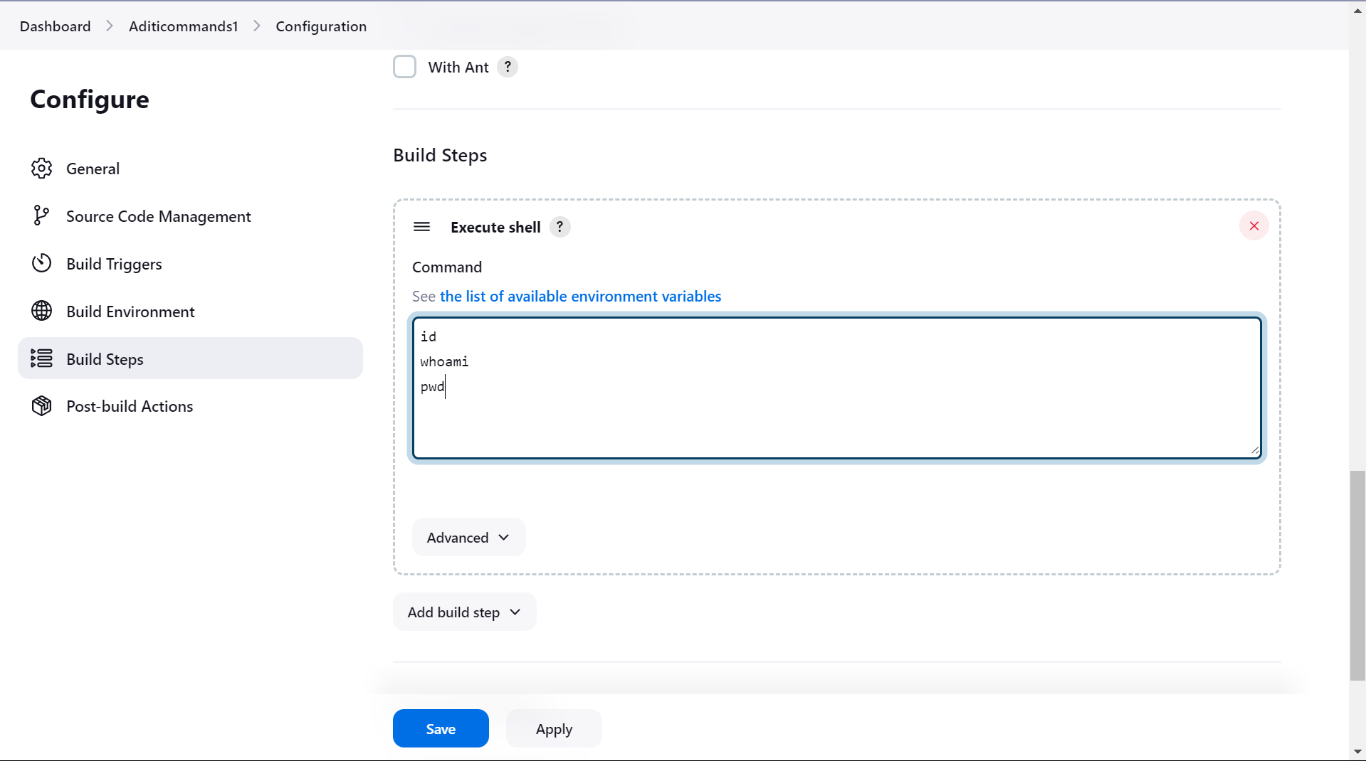

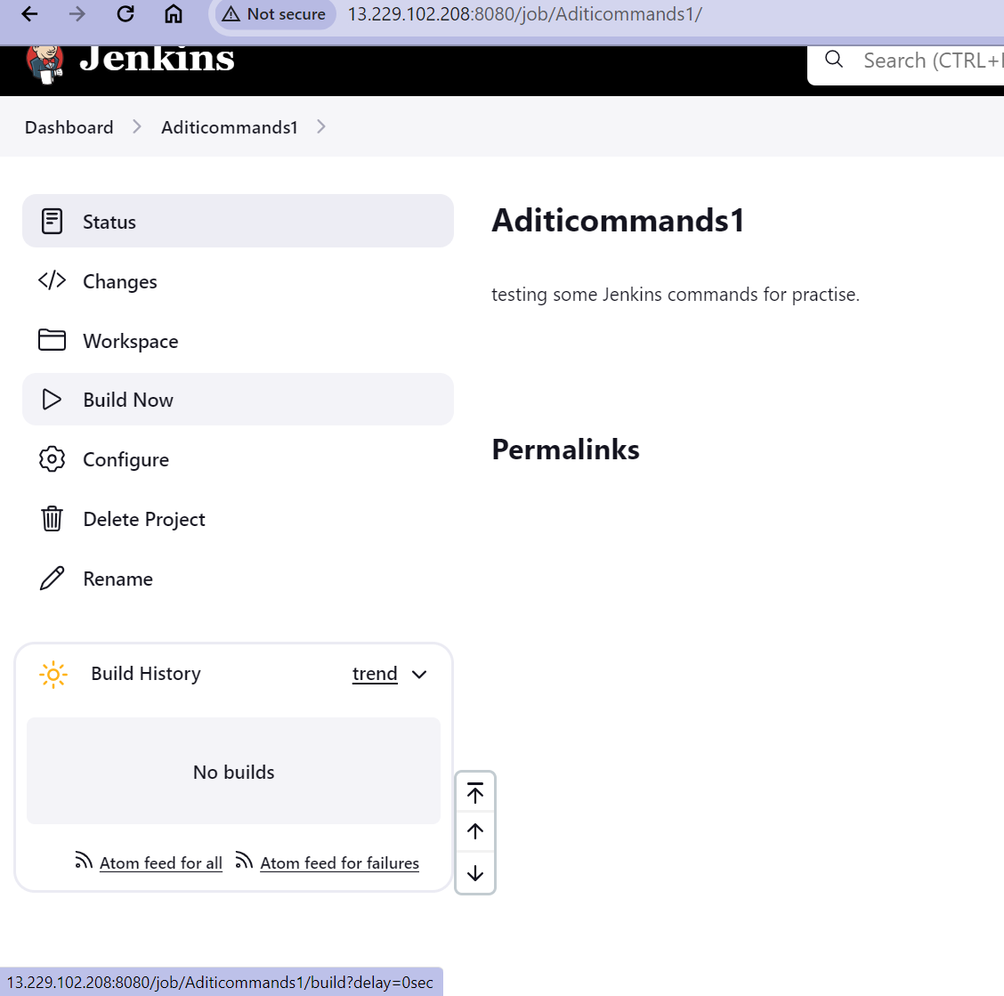

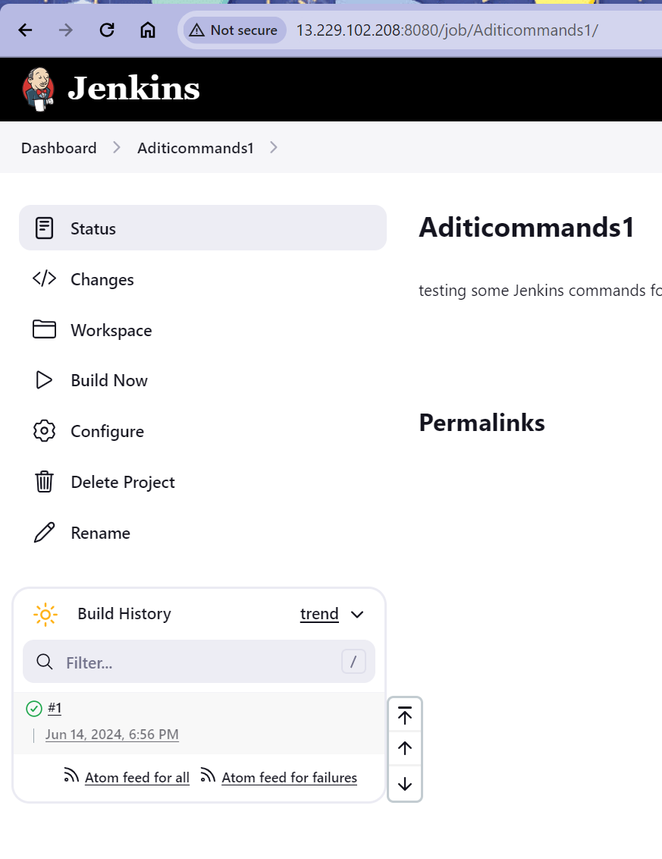

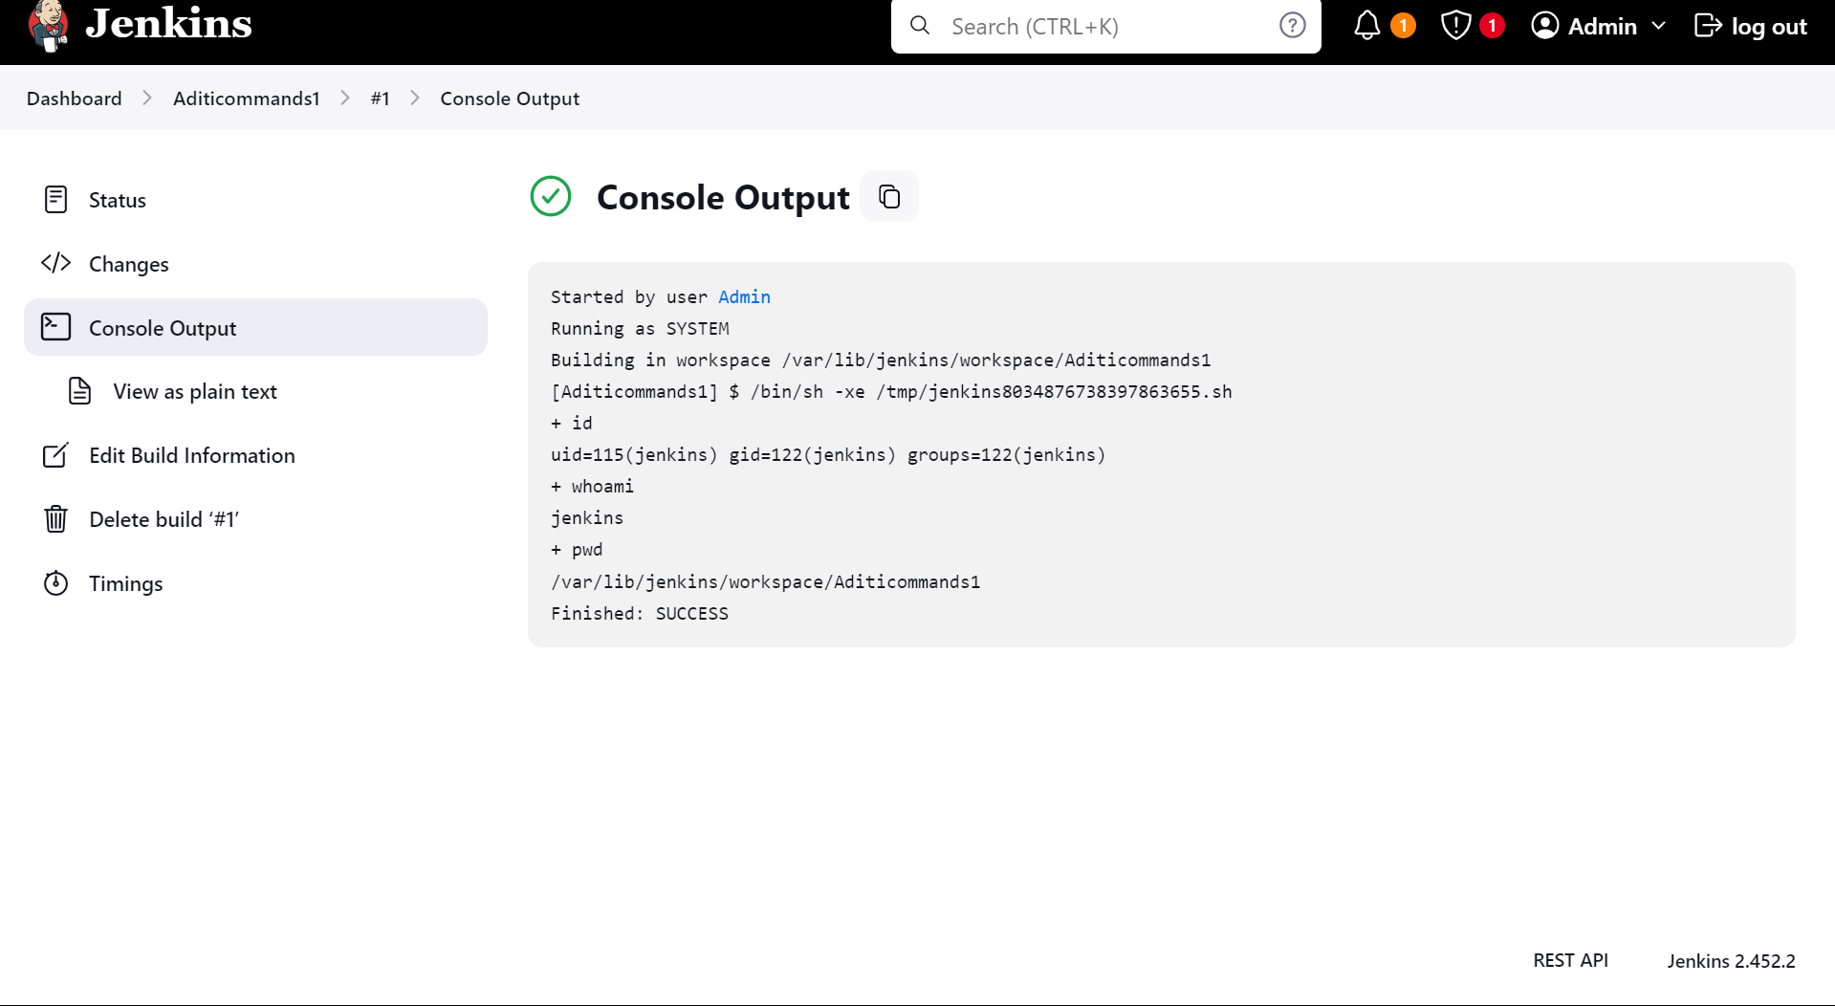

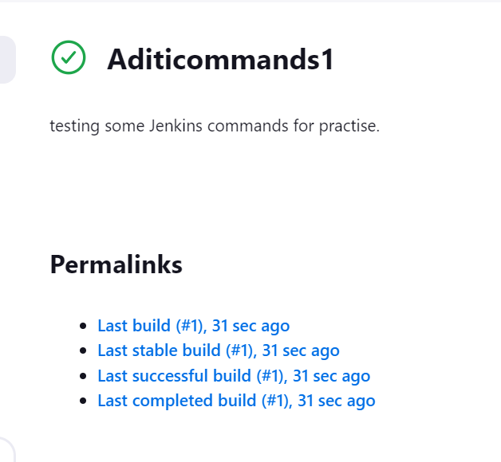

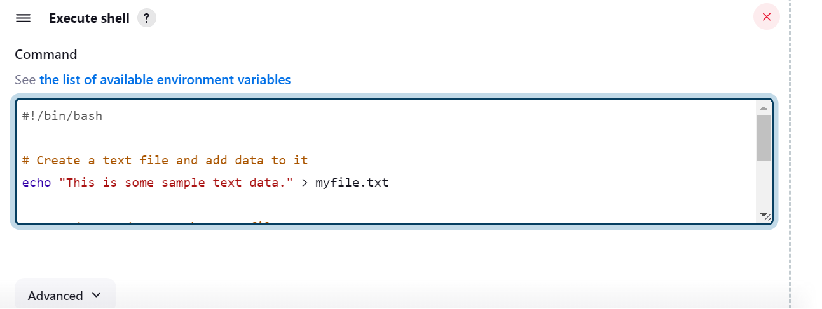

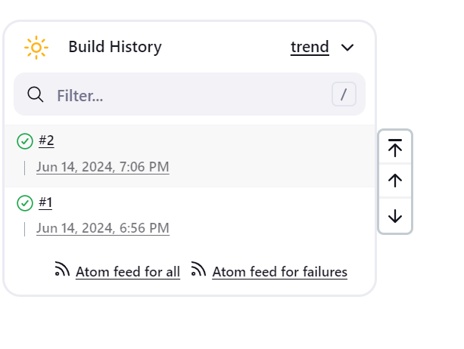

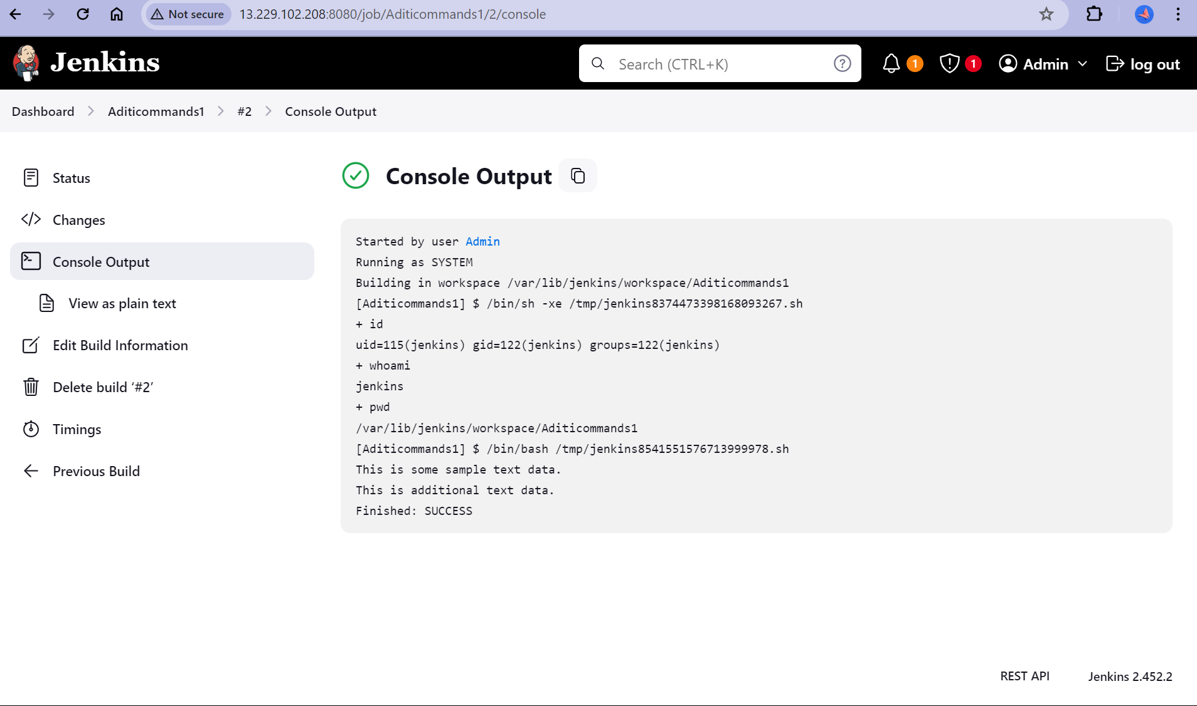

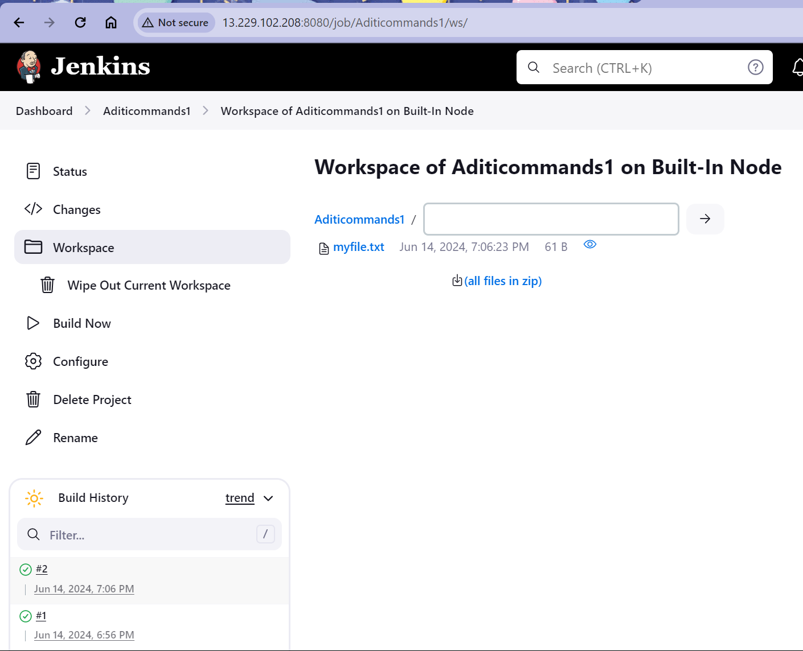

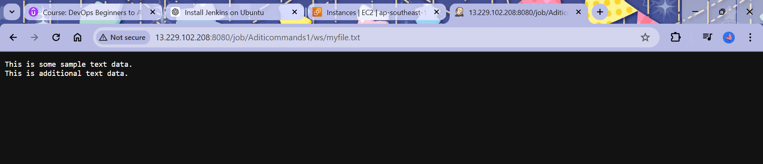

Let us now build an Actual job.

Fetch the source code from GitHub and build the artifacts using the mnv install command.

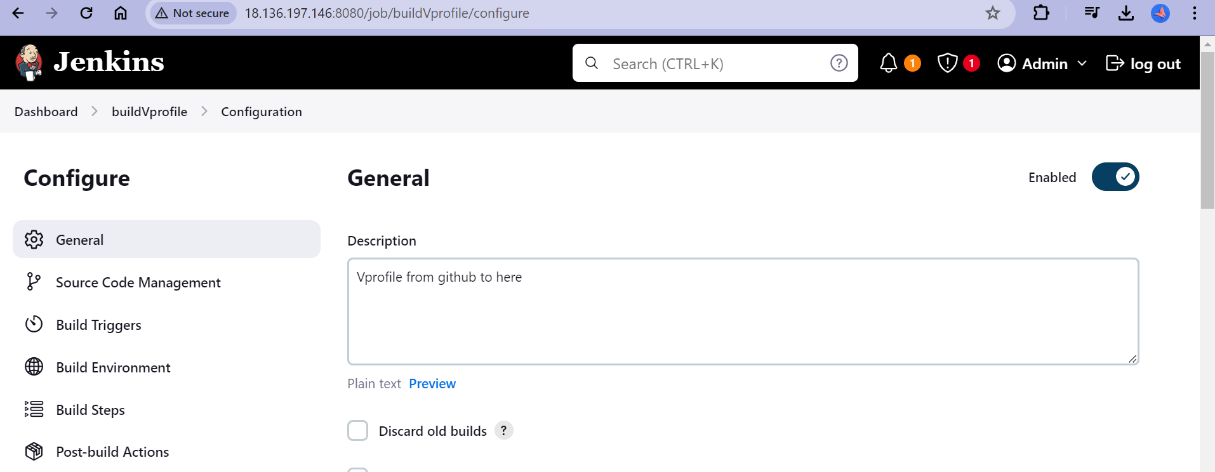

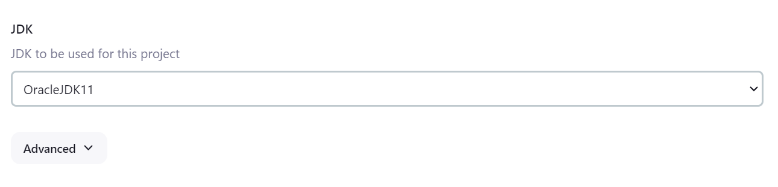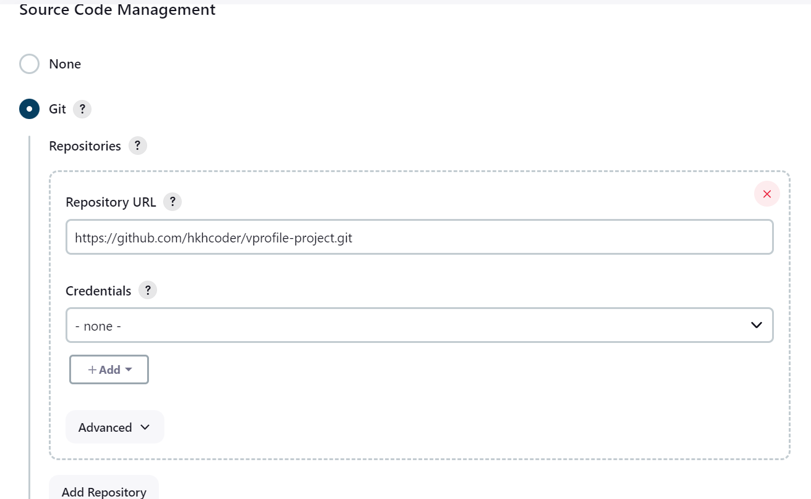

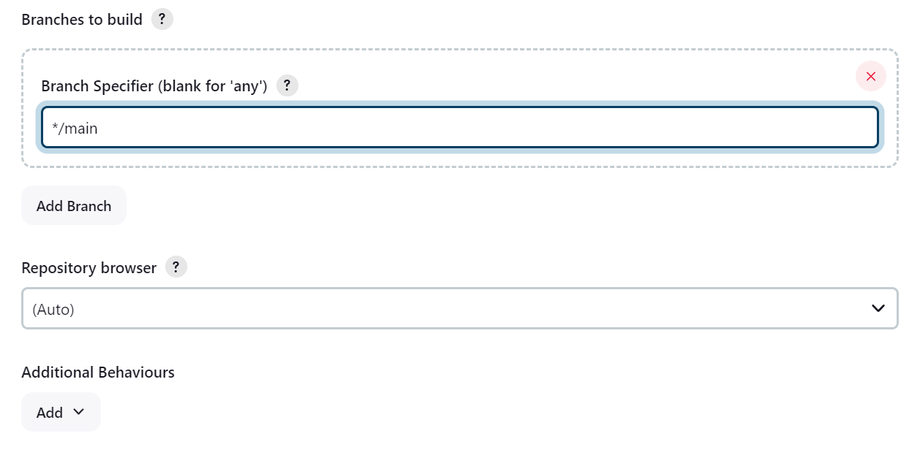

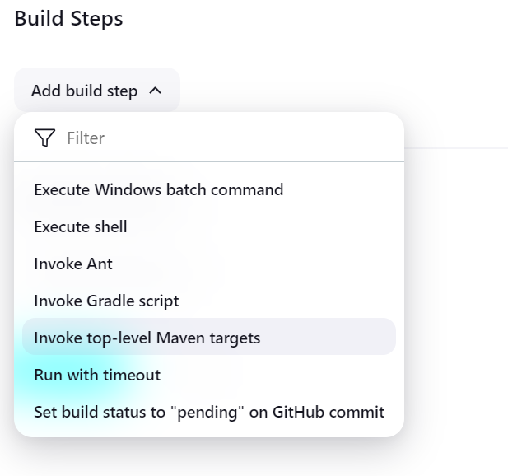

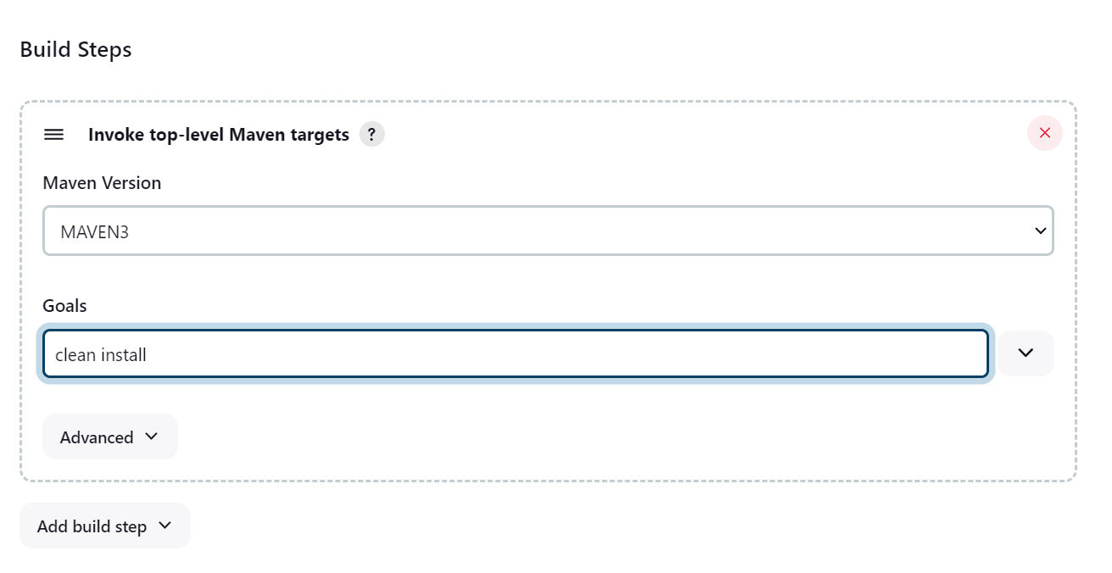

Click on Build

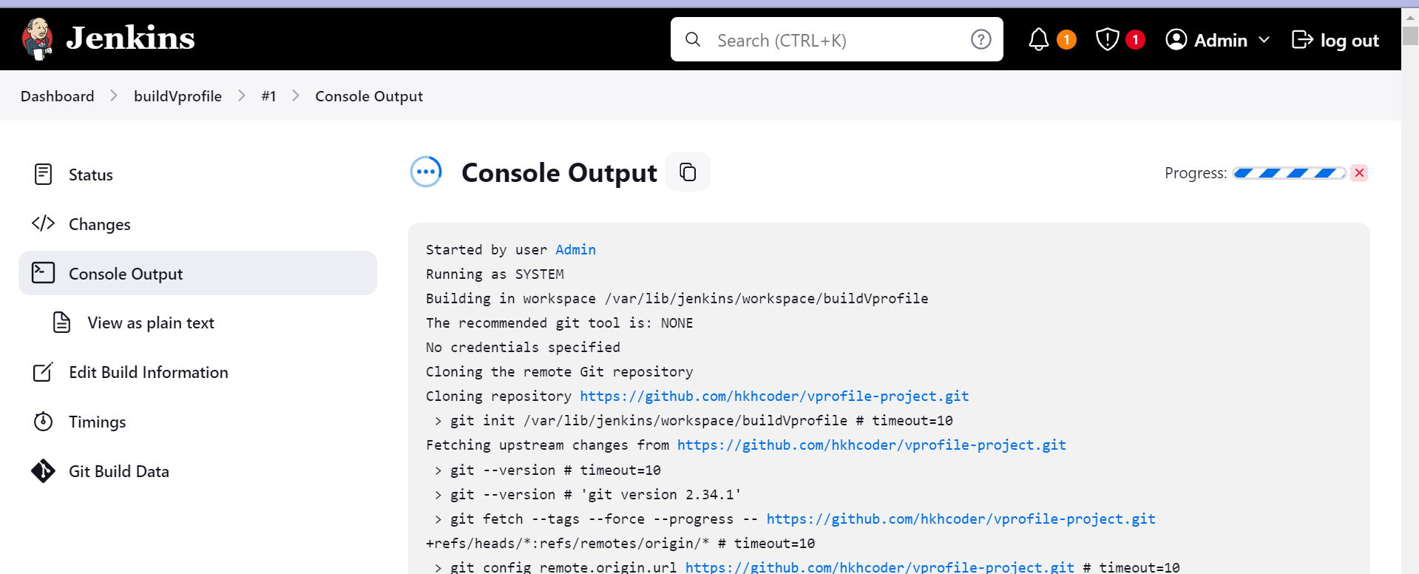

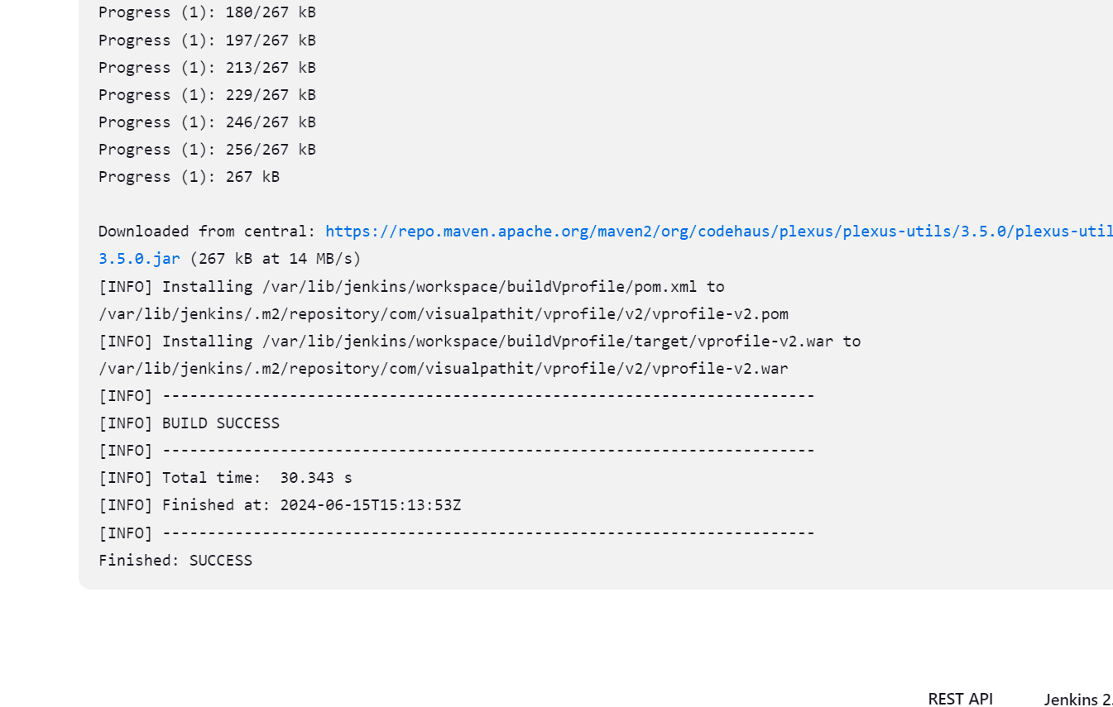

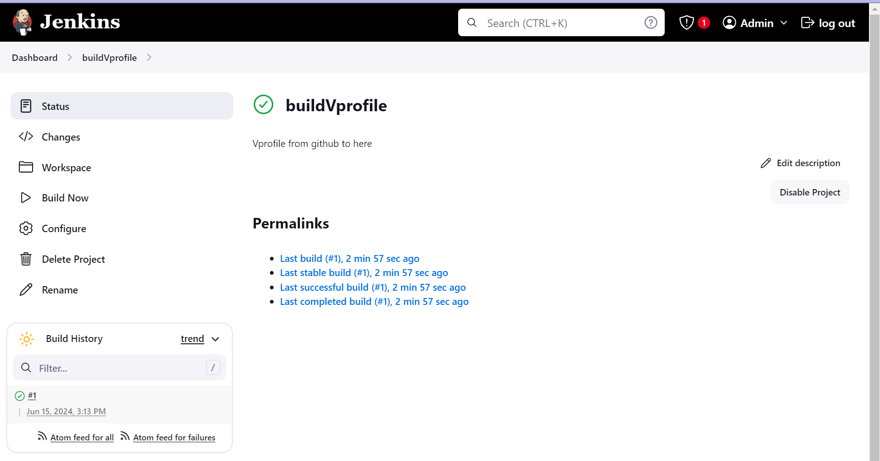

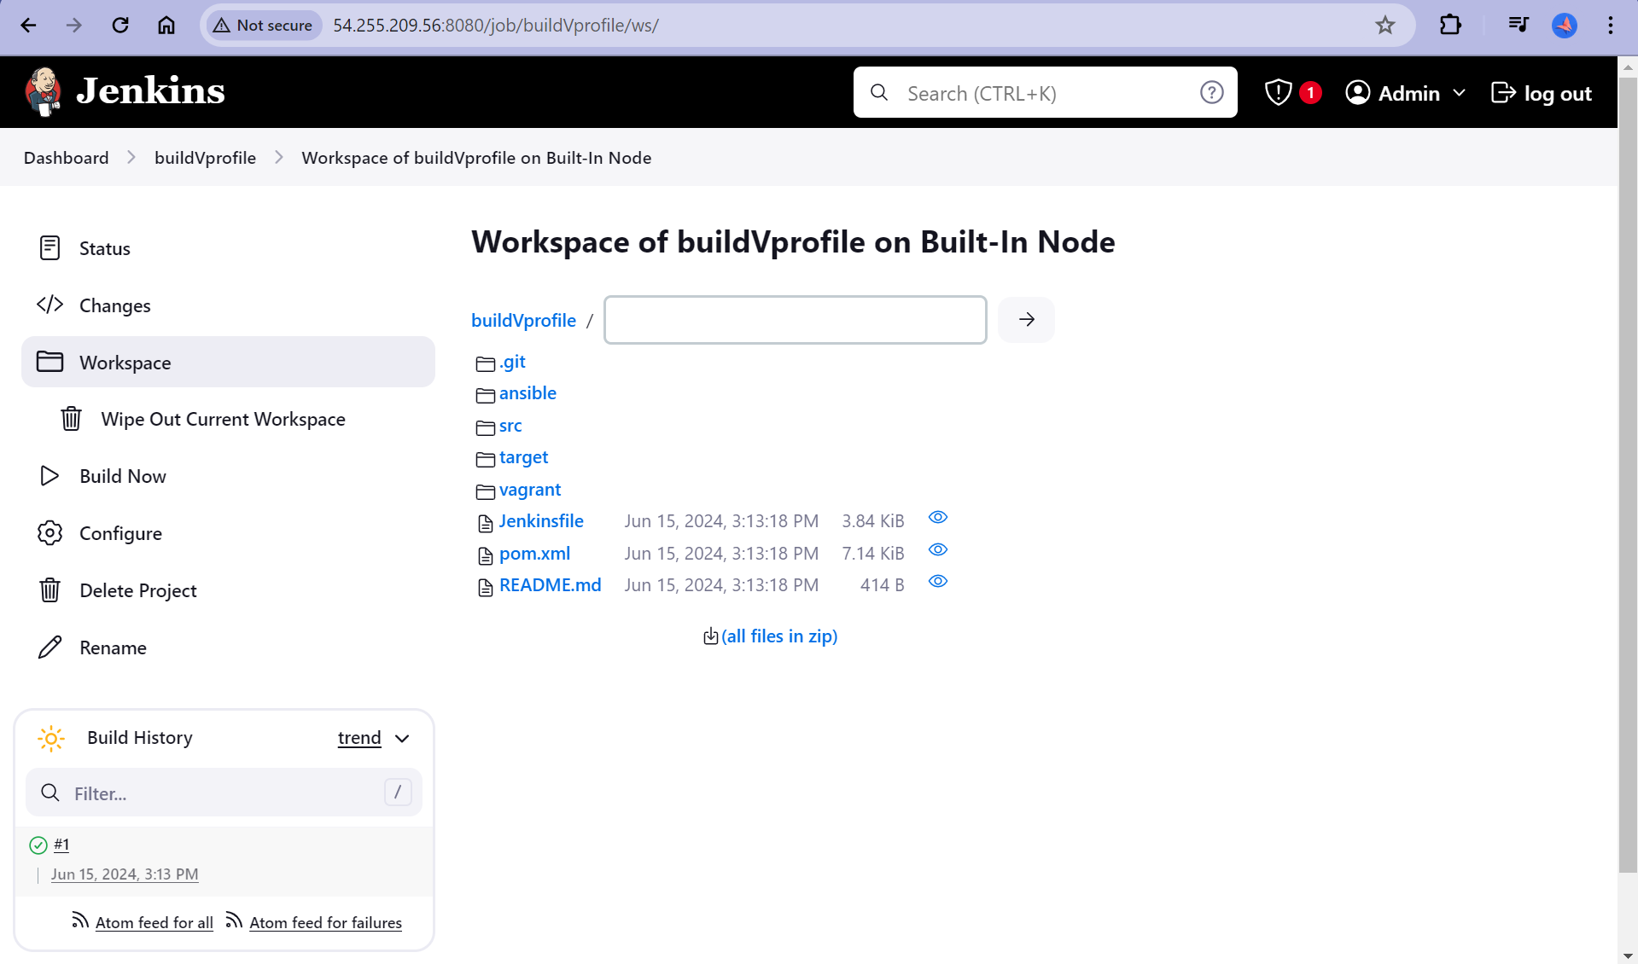

**Plugins, Versioning & more**

Whenever we refresh the dashboard our old artifacts are gone and new artifacts are created.

But what if we have to preserve our old artifacts?

We will do it through shell commands.

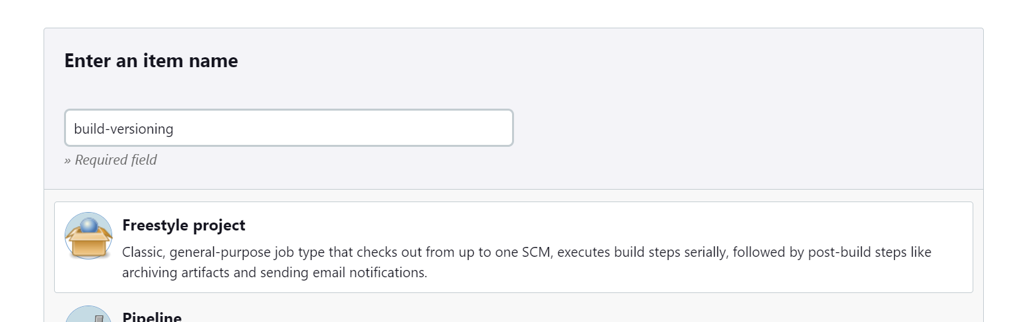

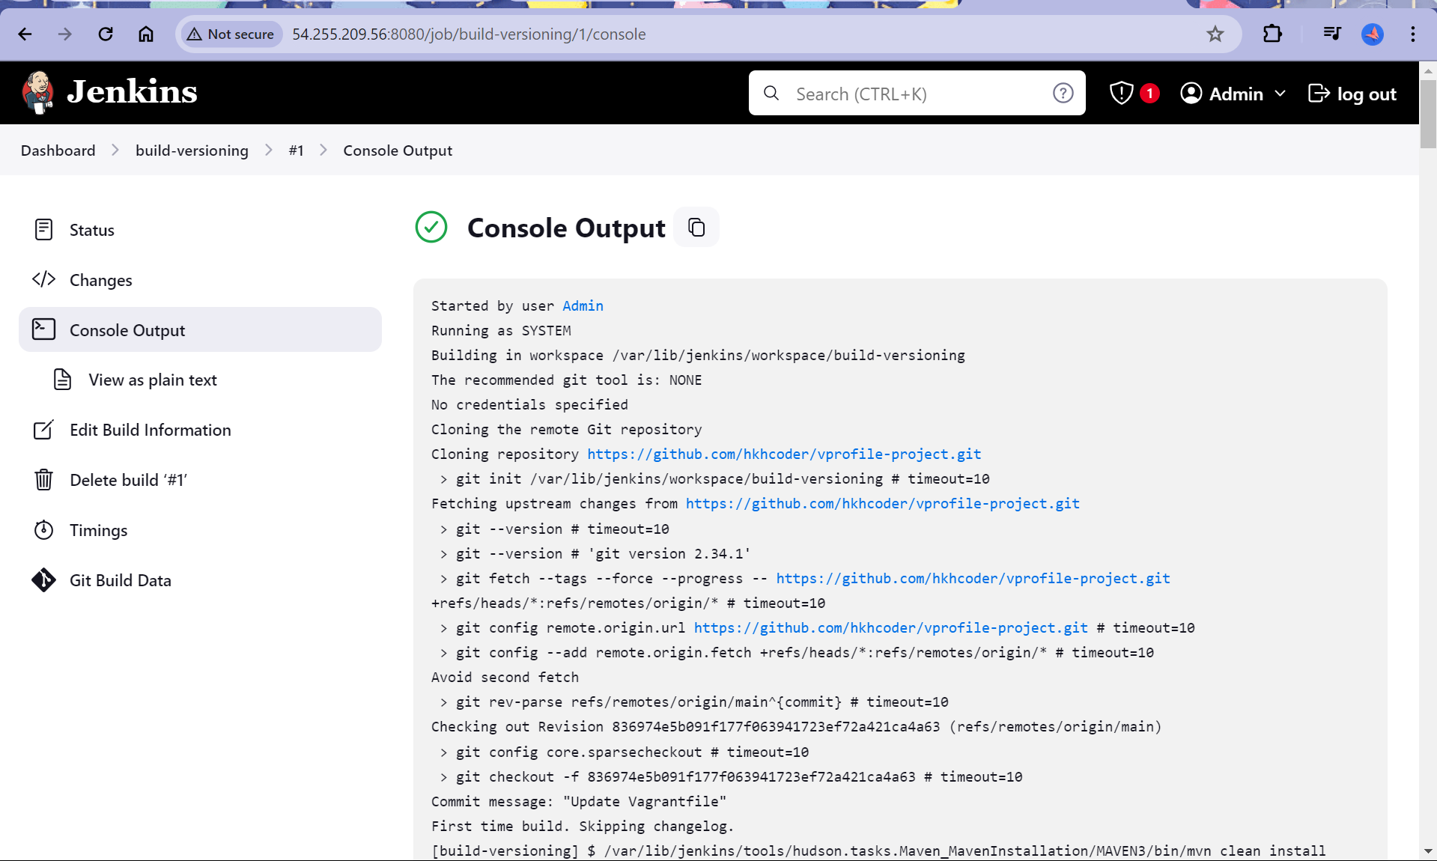

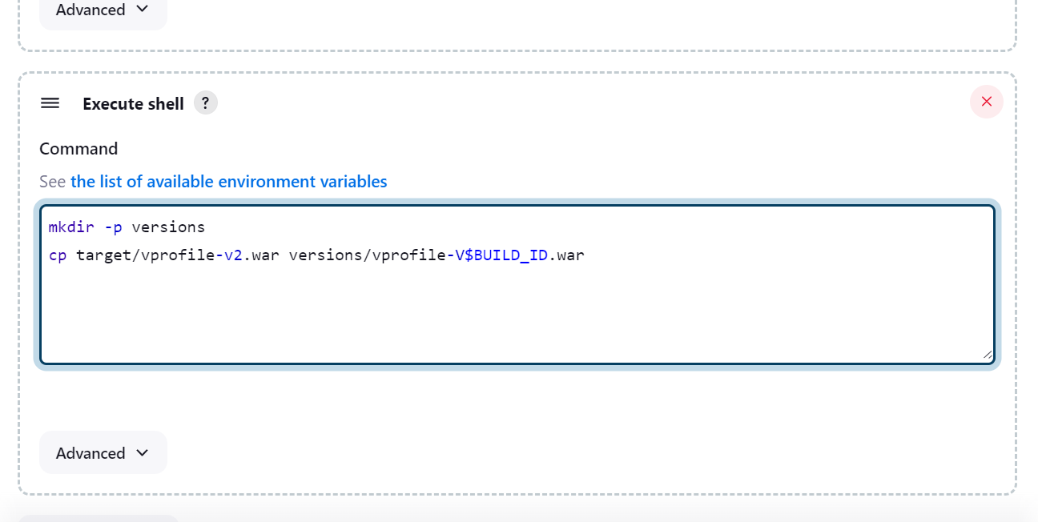

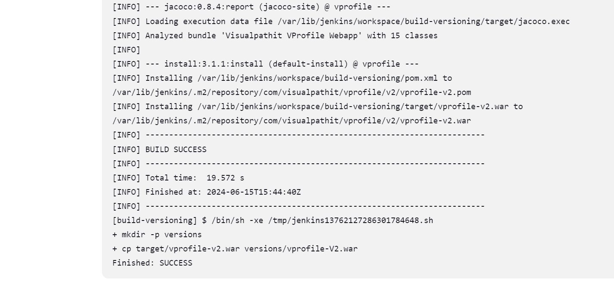

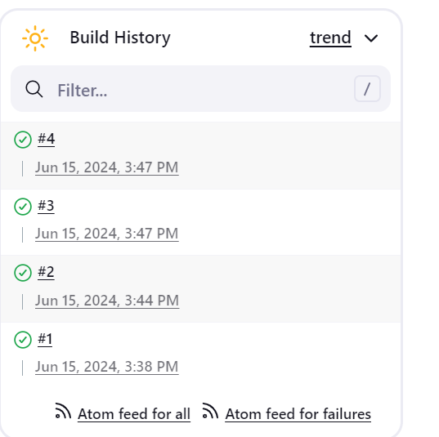 After running many build commands.

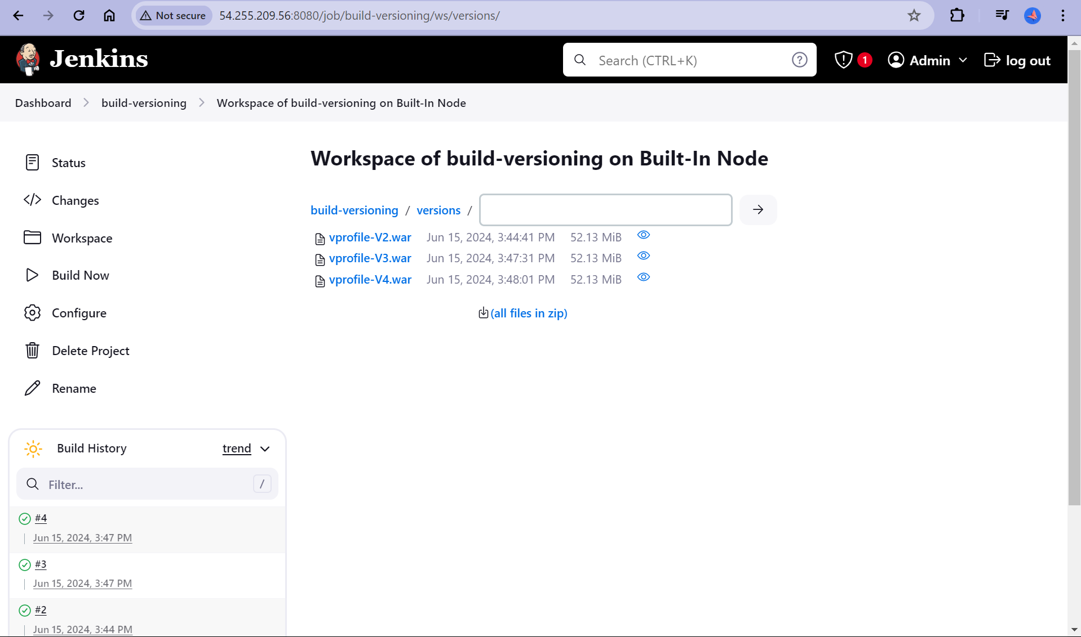

We can see different .war files which have all versions.

Now I want to specify my own user and argument

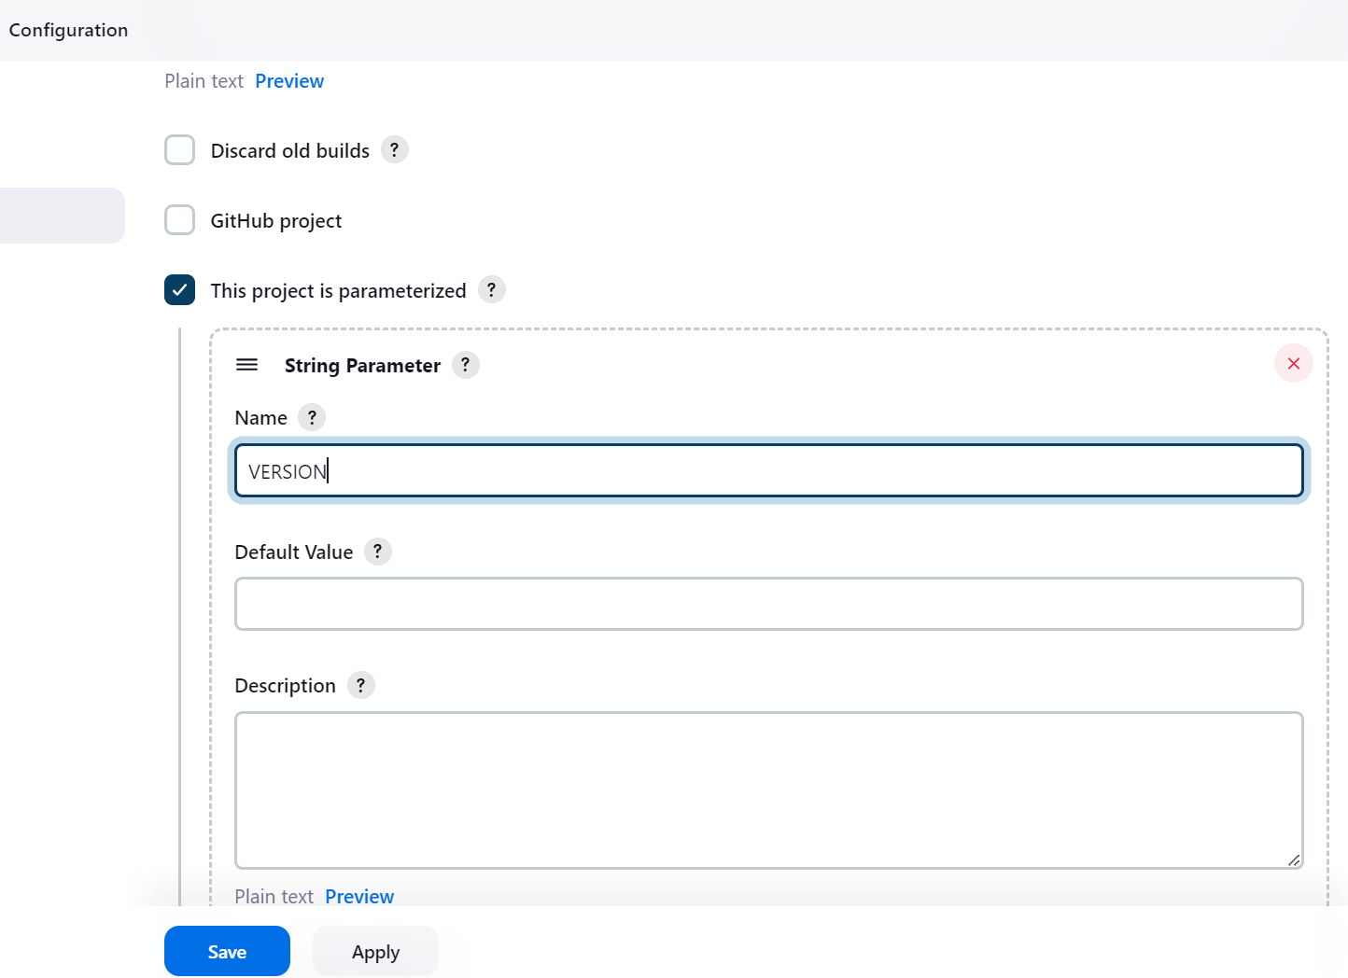

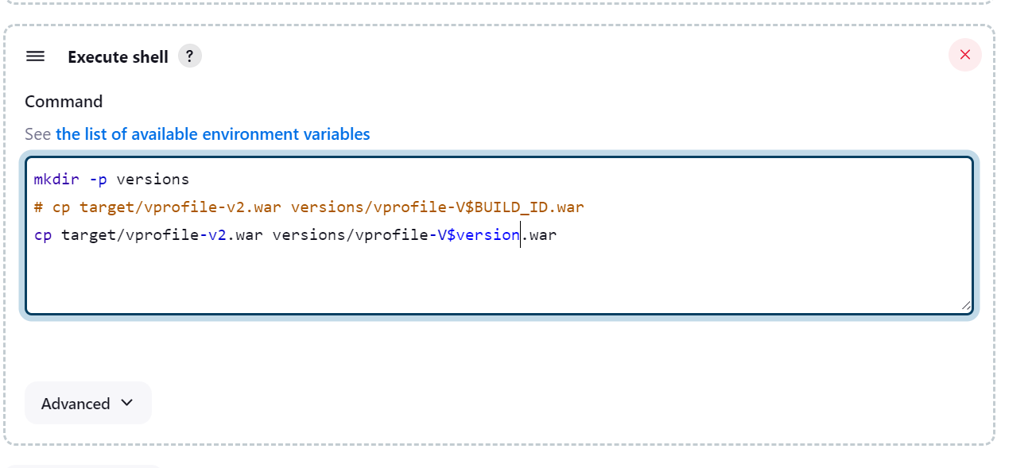

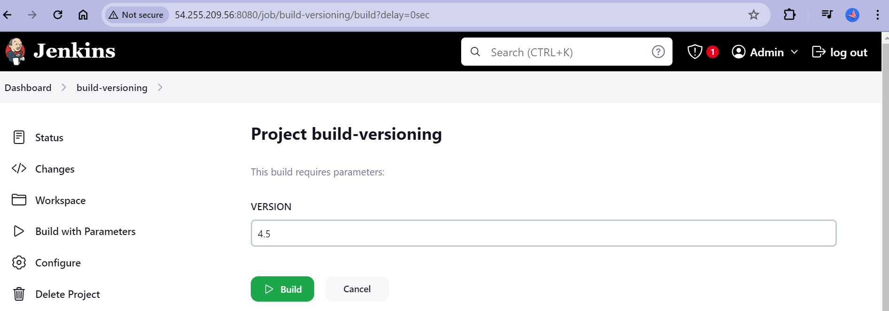

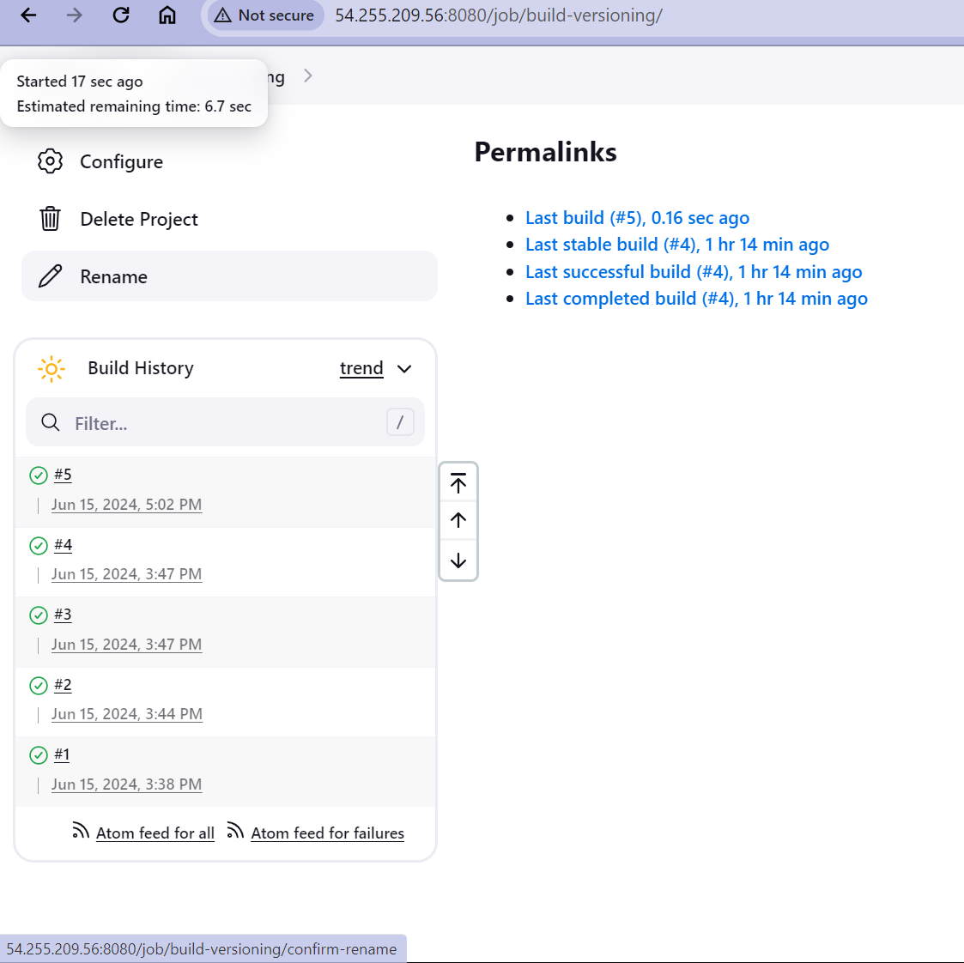

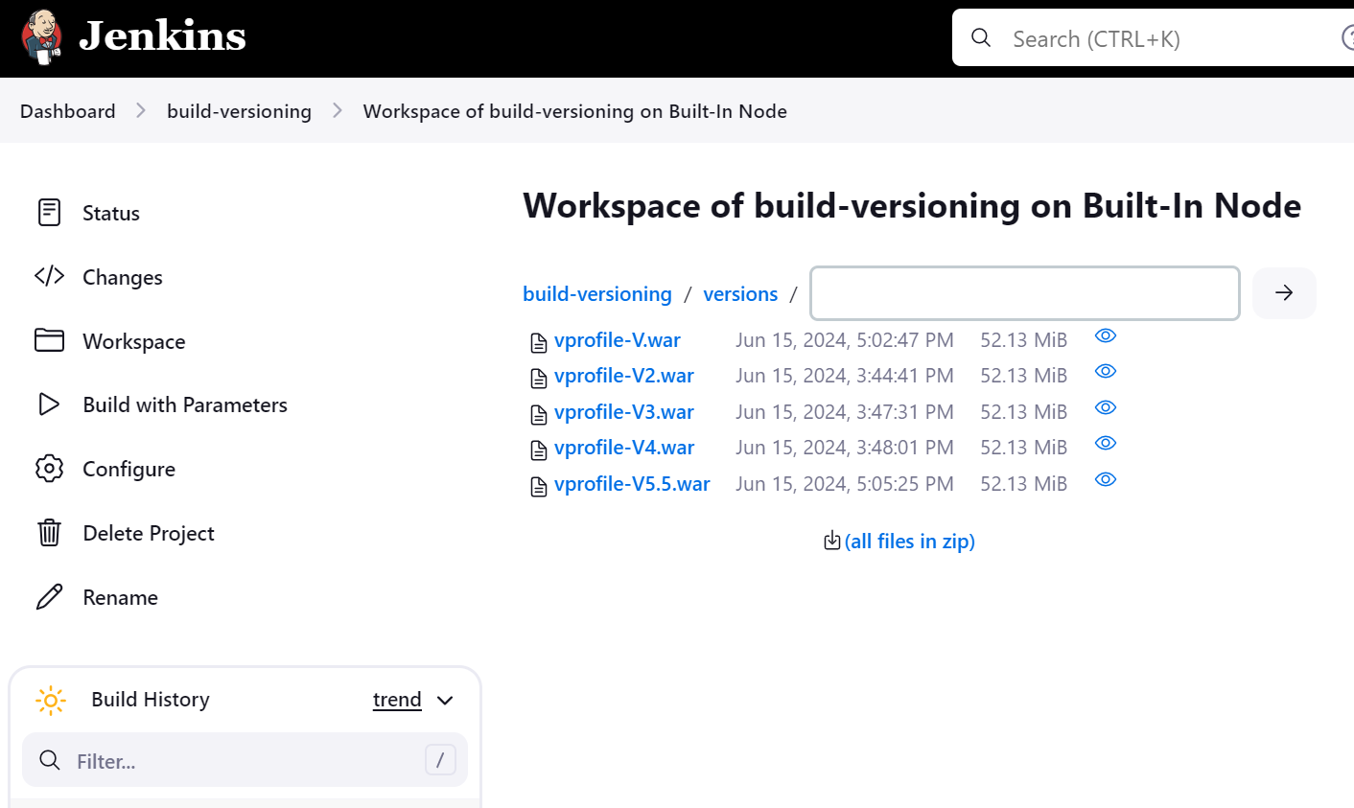

**Flow of Continous Integration**

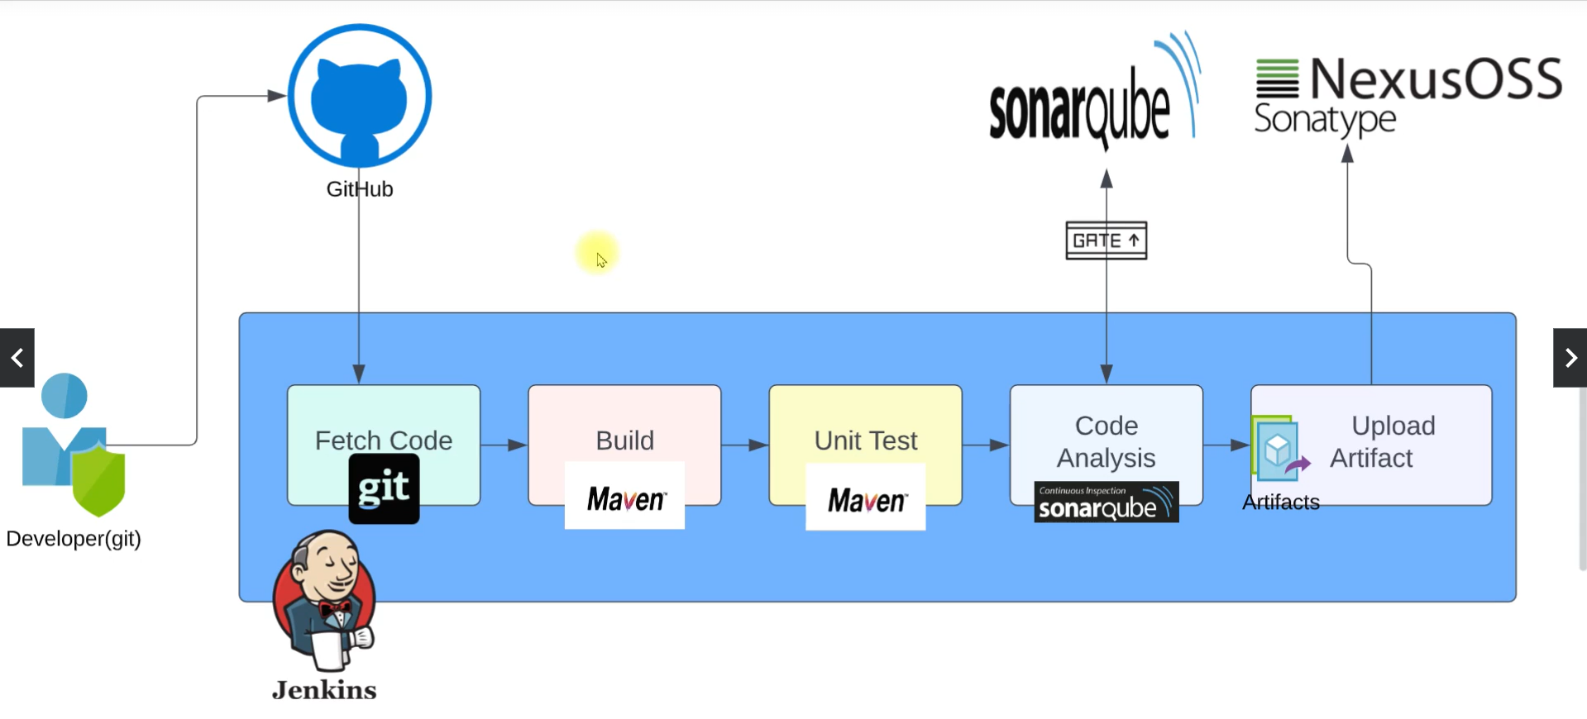

Steps of execution

* Jenkins setup
* Nexus Setup
* Sonarqube Setup
* Security Group
* Plugins
* Integrate
  + Nexus
  + Sonarqube
* Write Pipeline script
* Set notification

1. Jenkins setup is already done.
2. Let us set Nexus

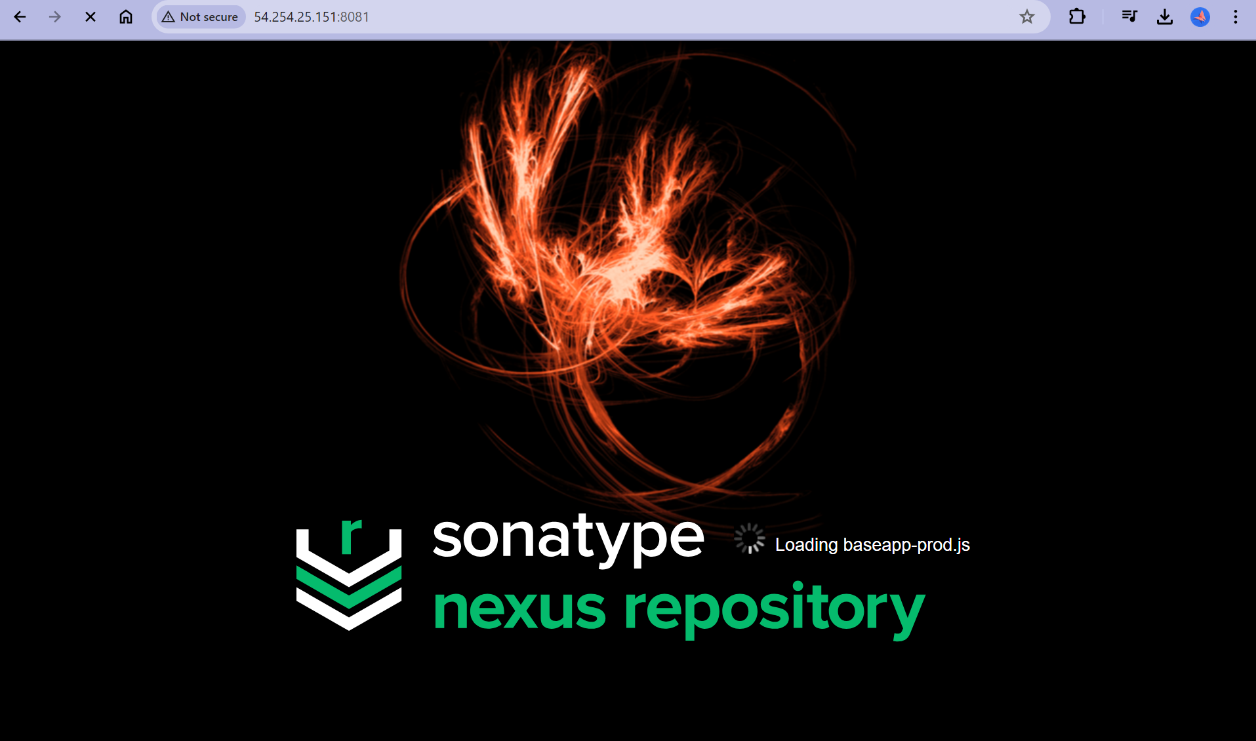

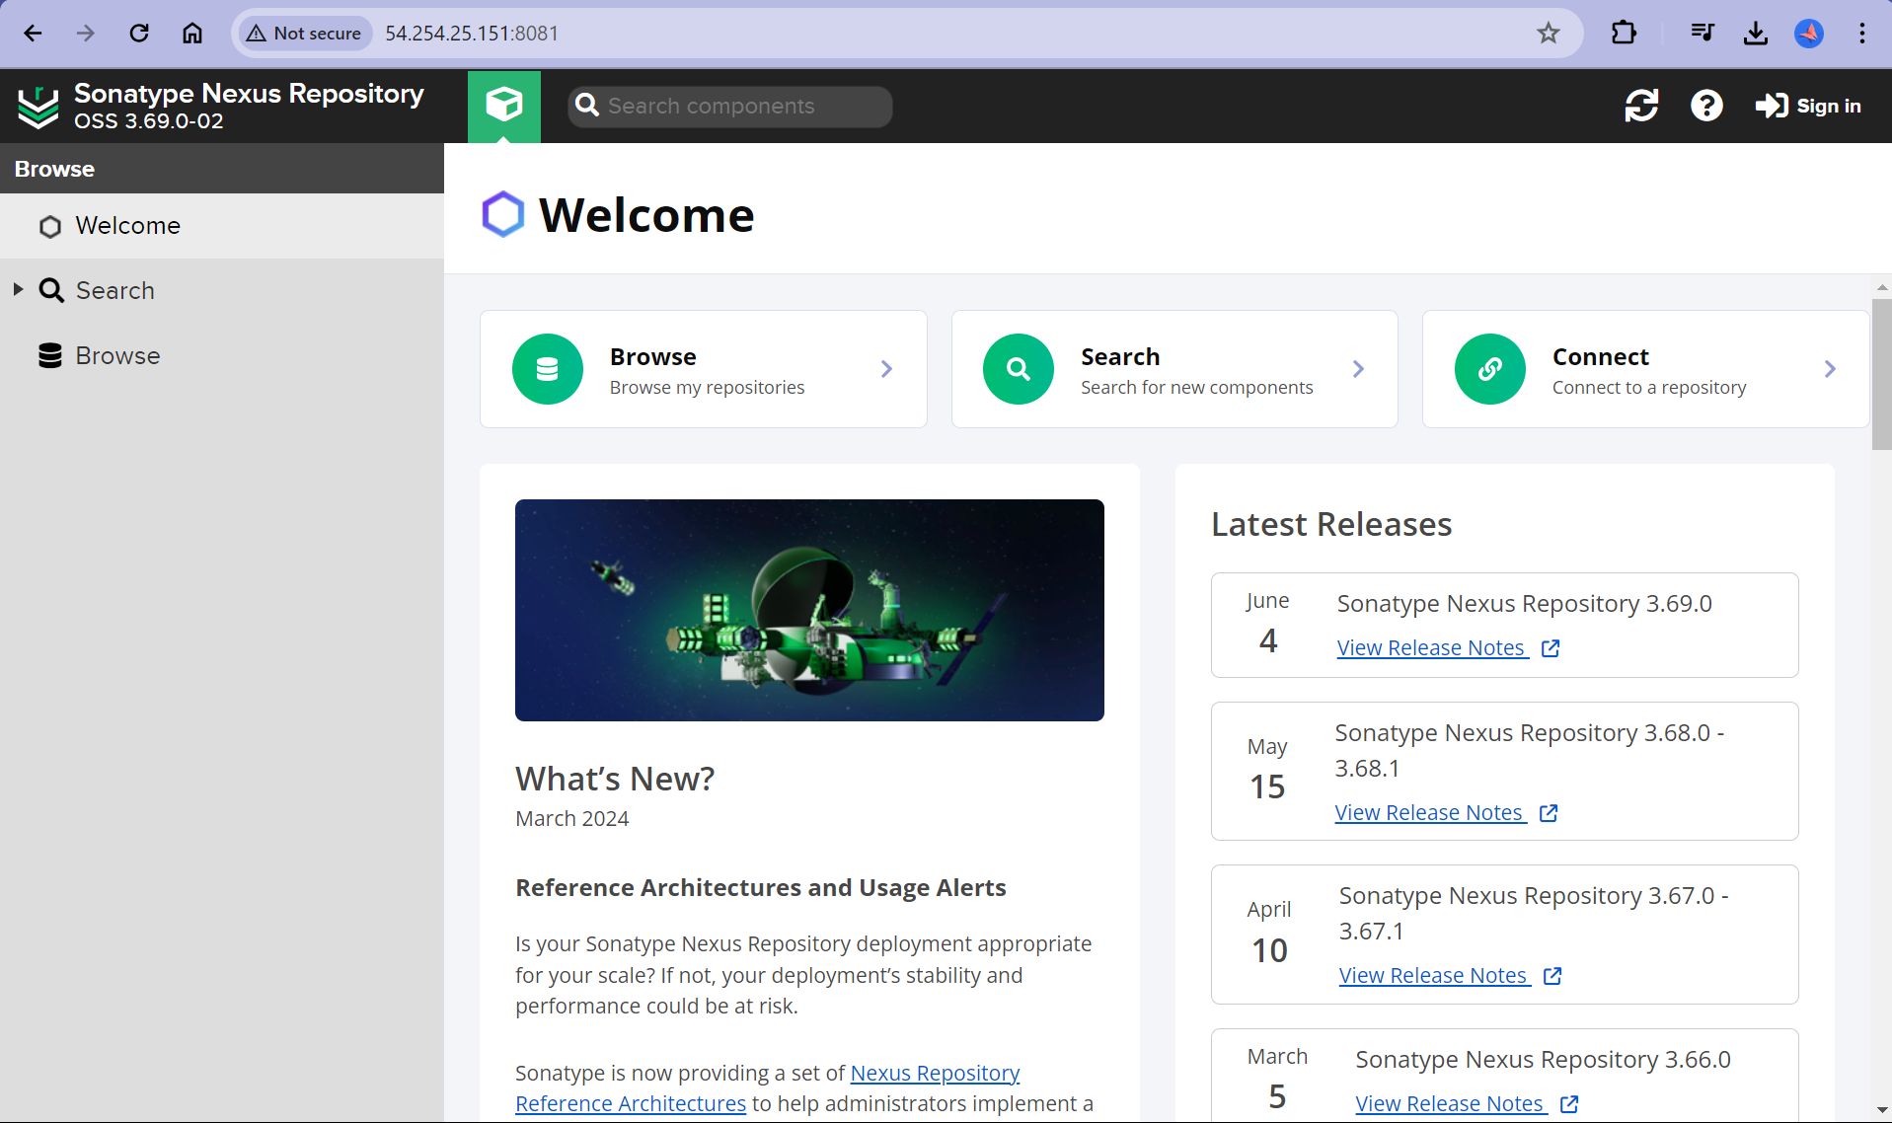

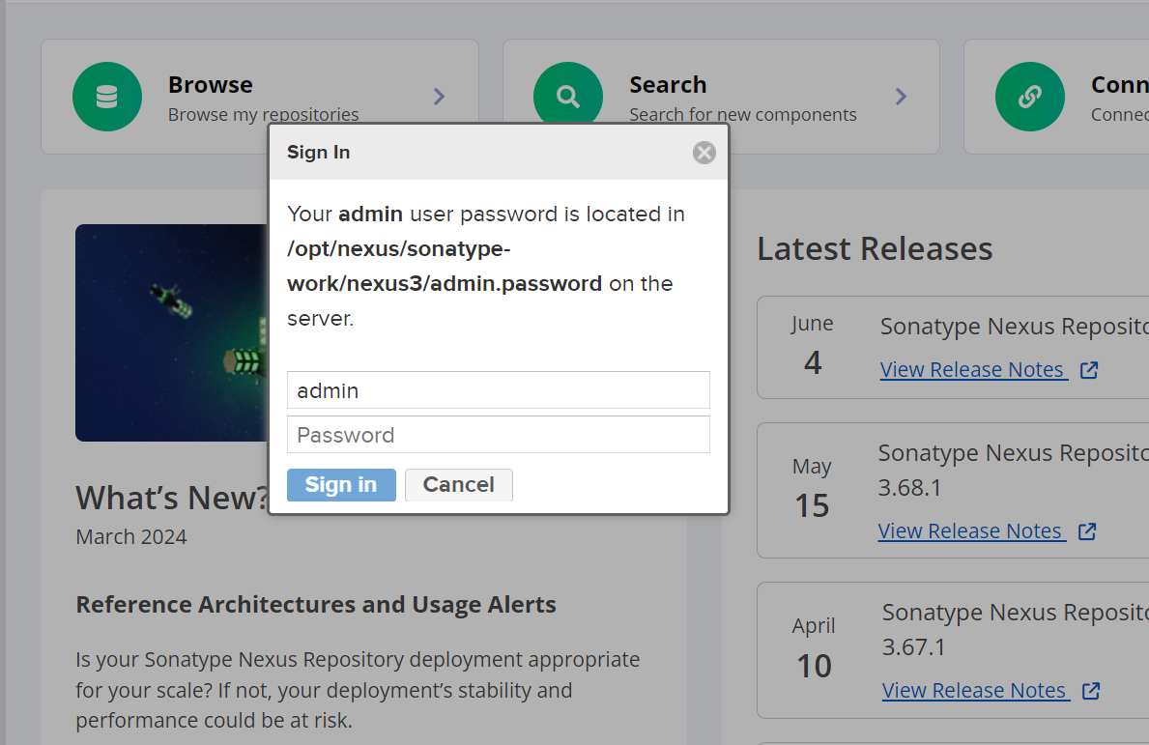

Set the initial password and login to sonar

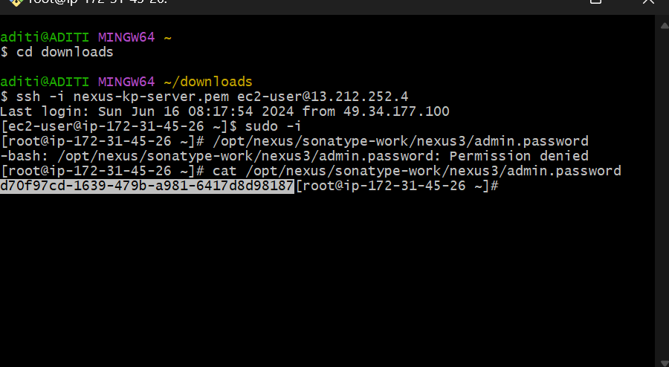

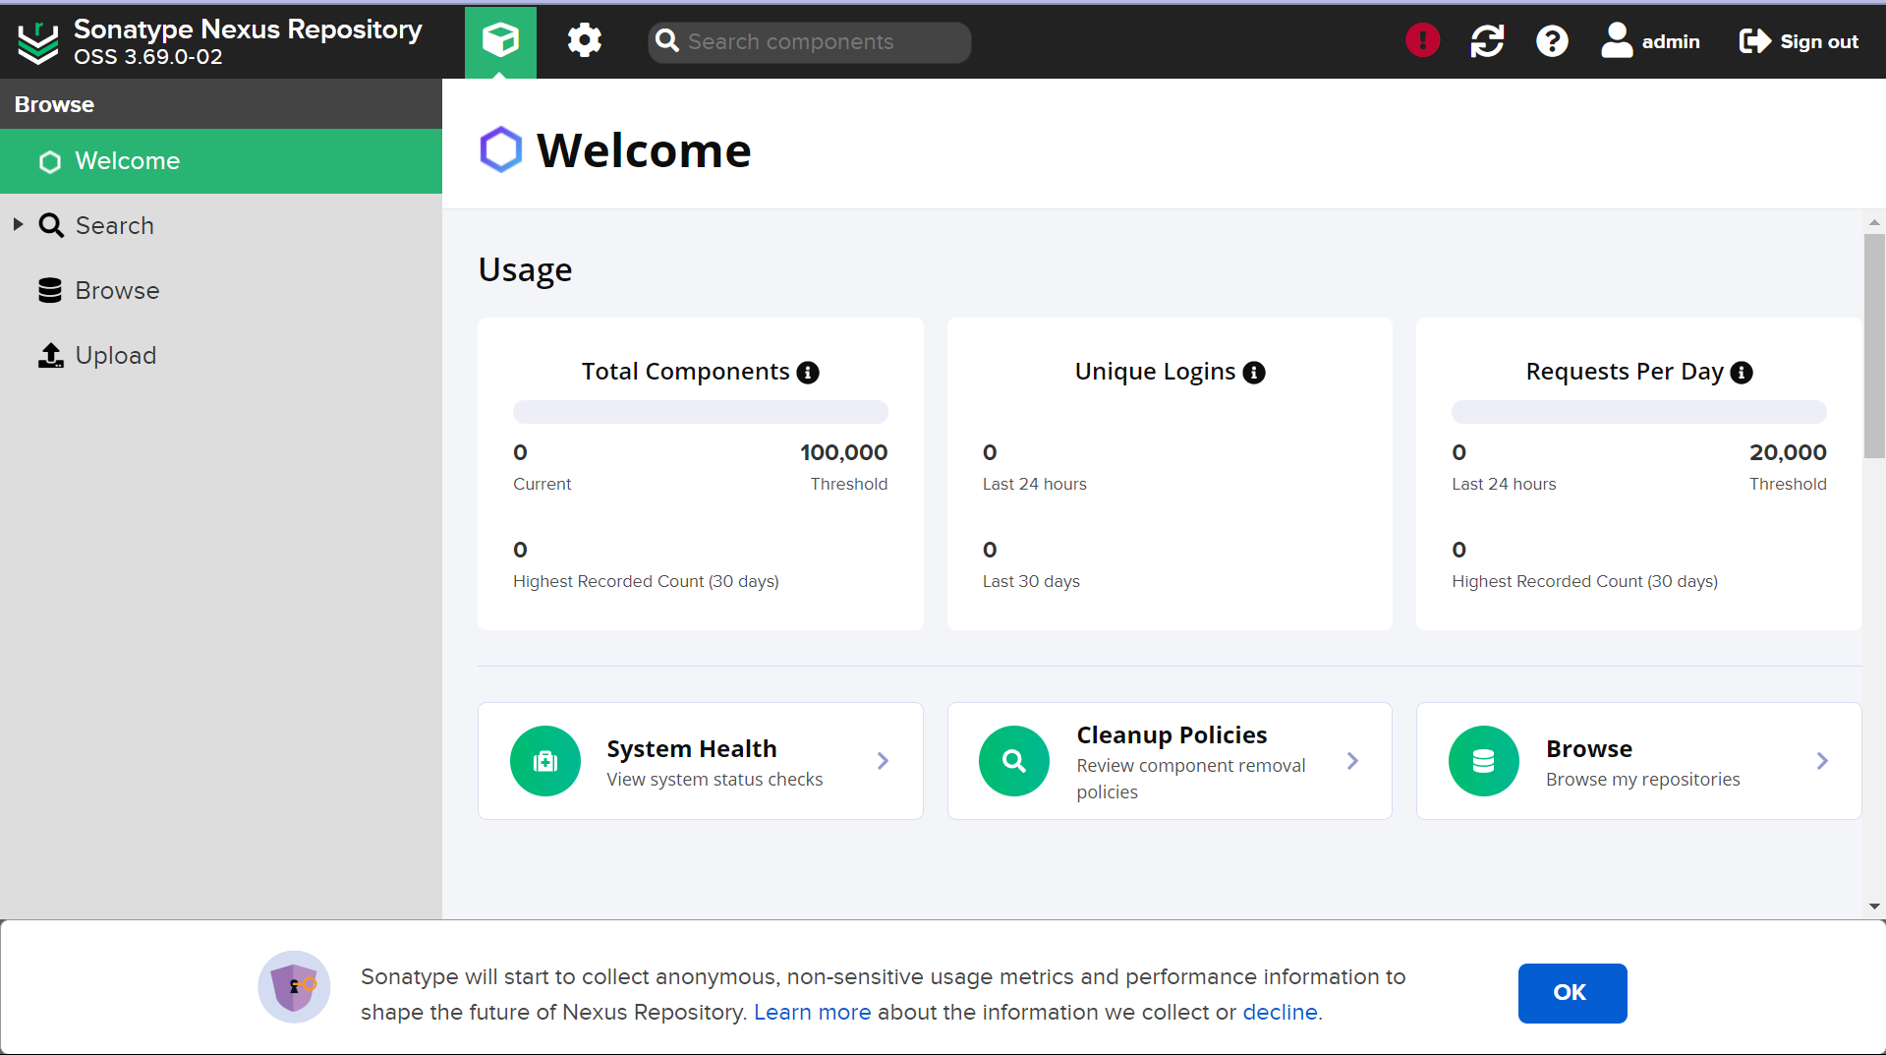

1. Let us set Sonarqube

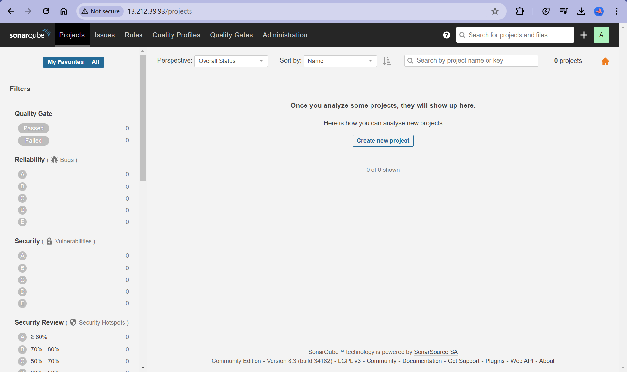

1. Security Groups were all set during instance launch

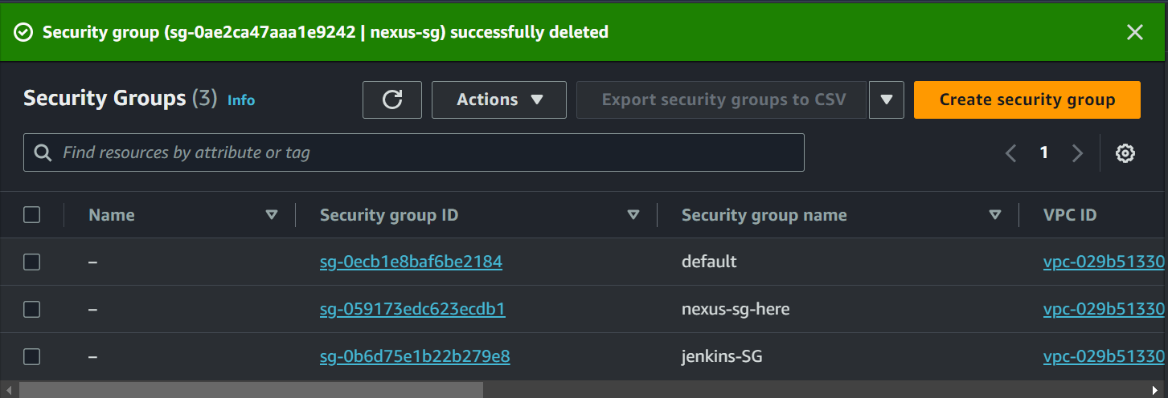

1. Plugins for CI

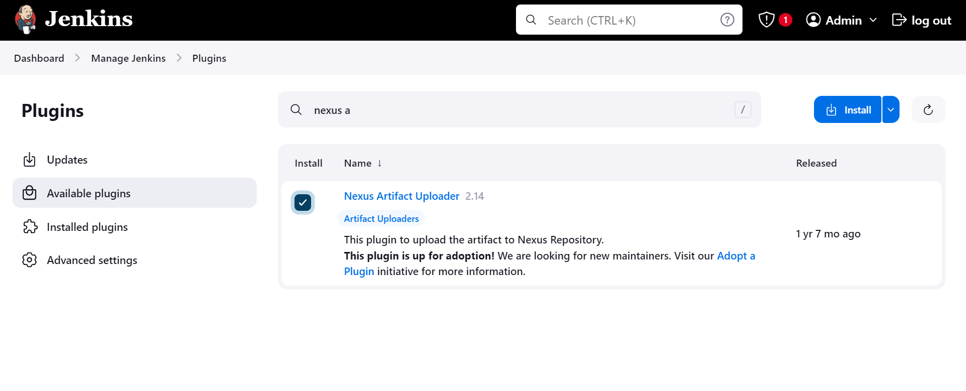

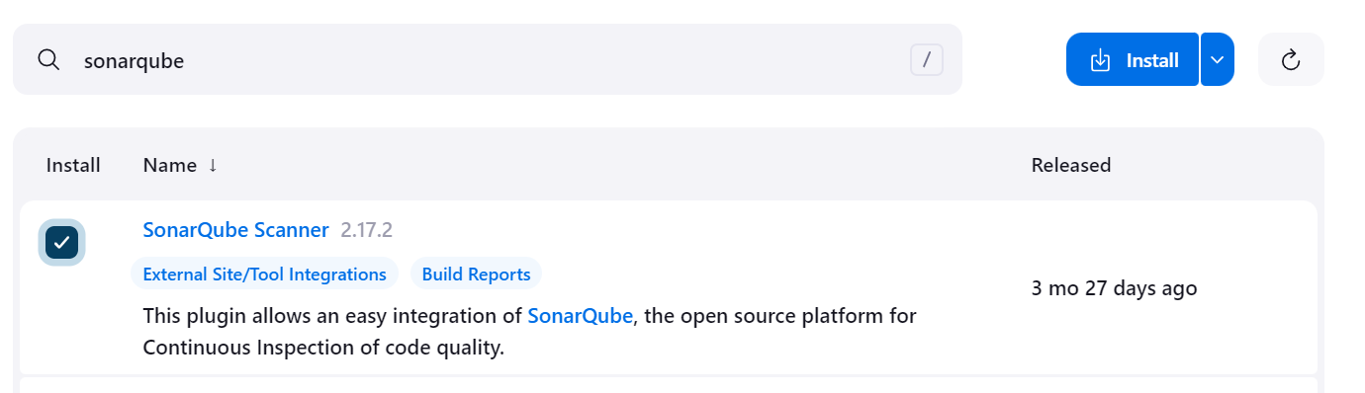

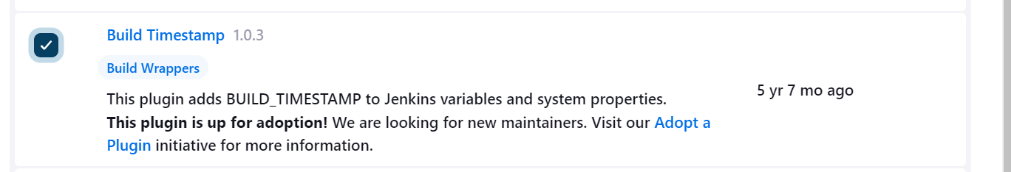

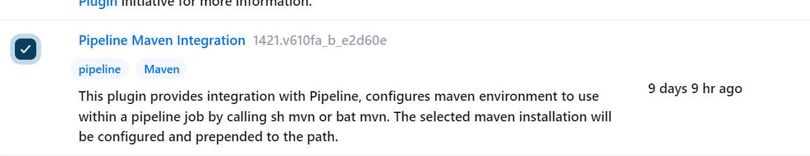

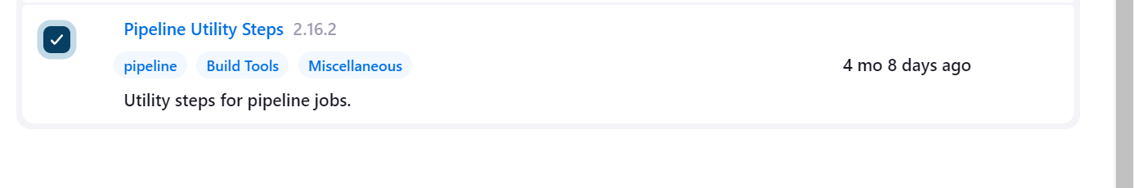

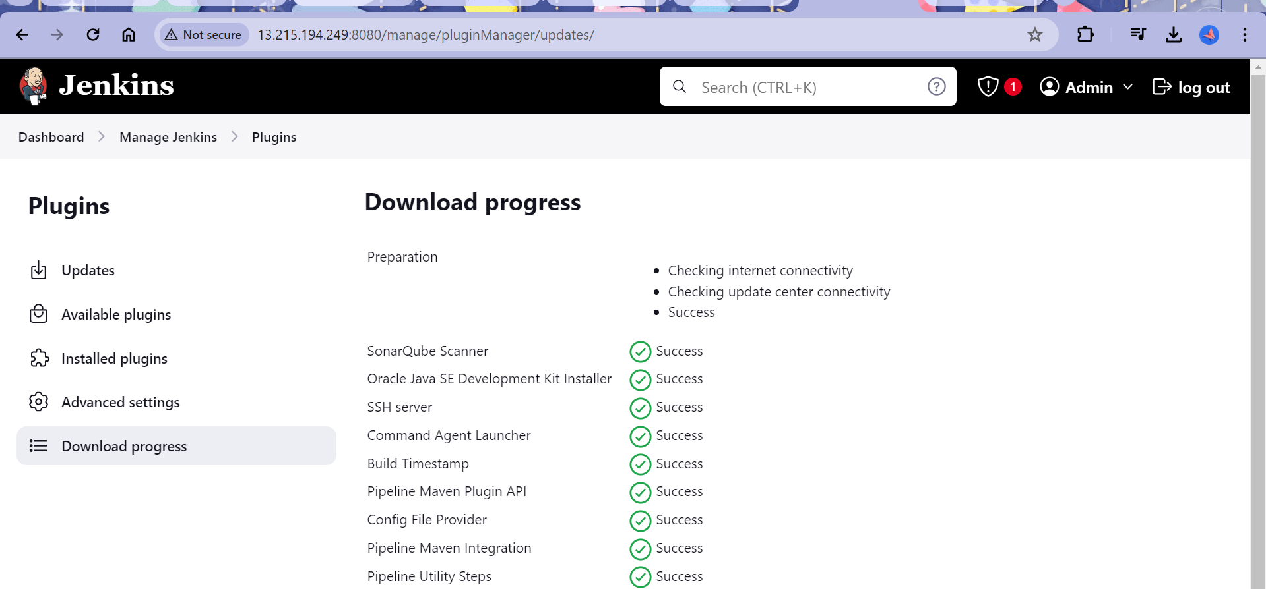

1. Pipeline as Code

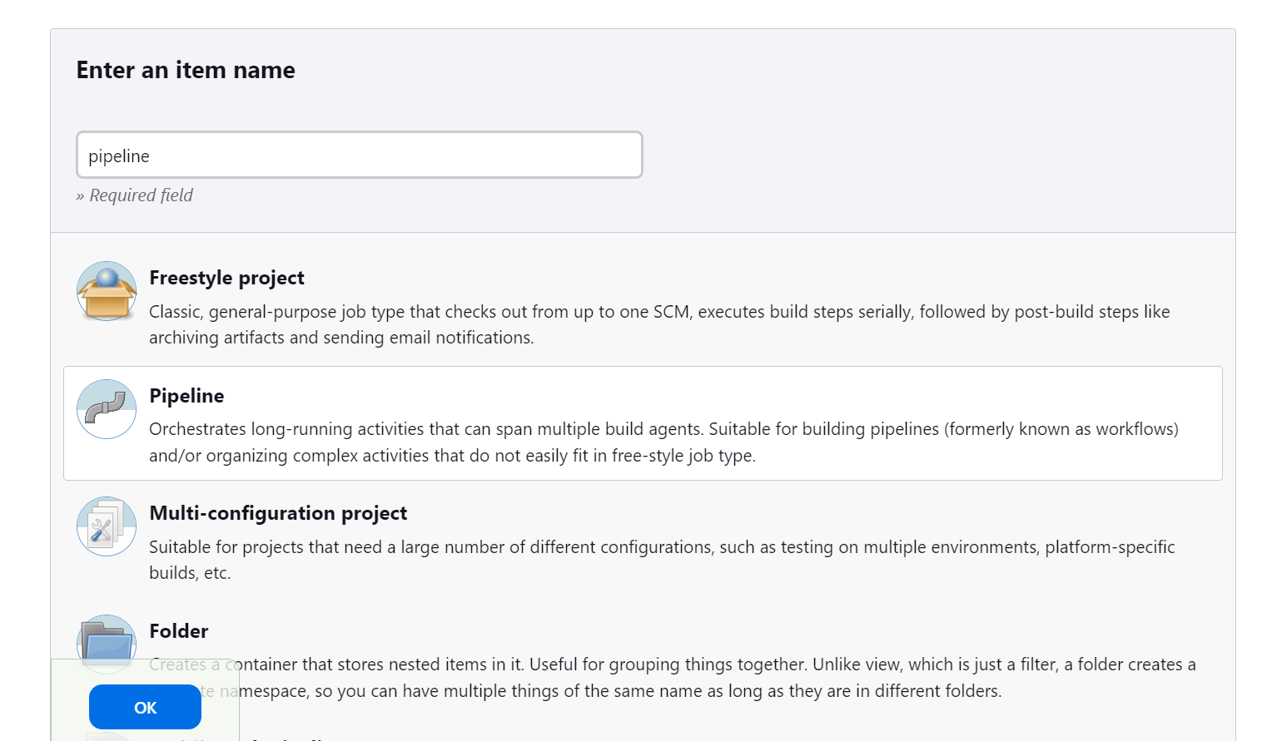

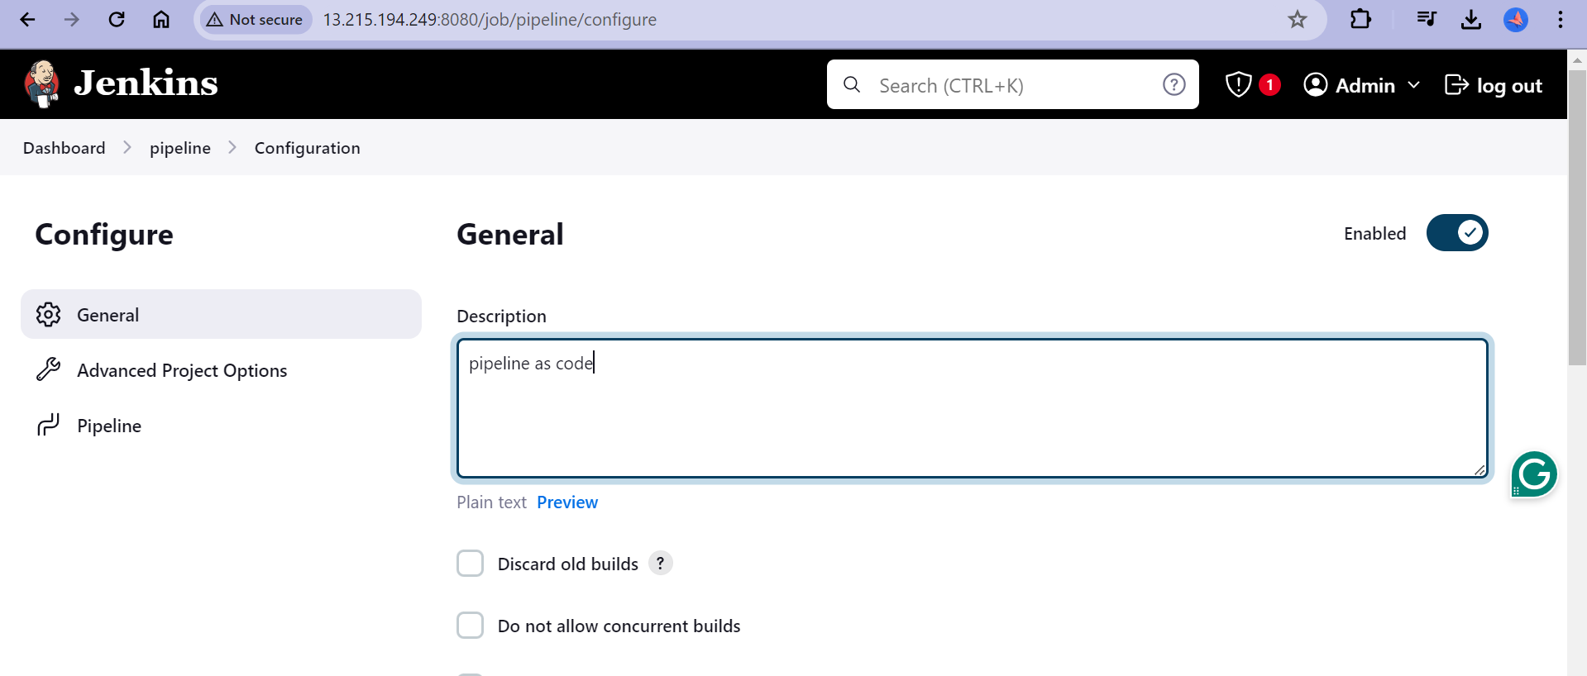

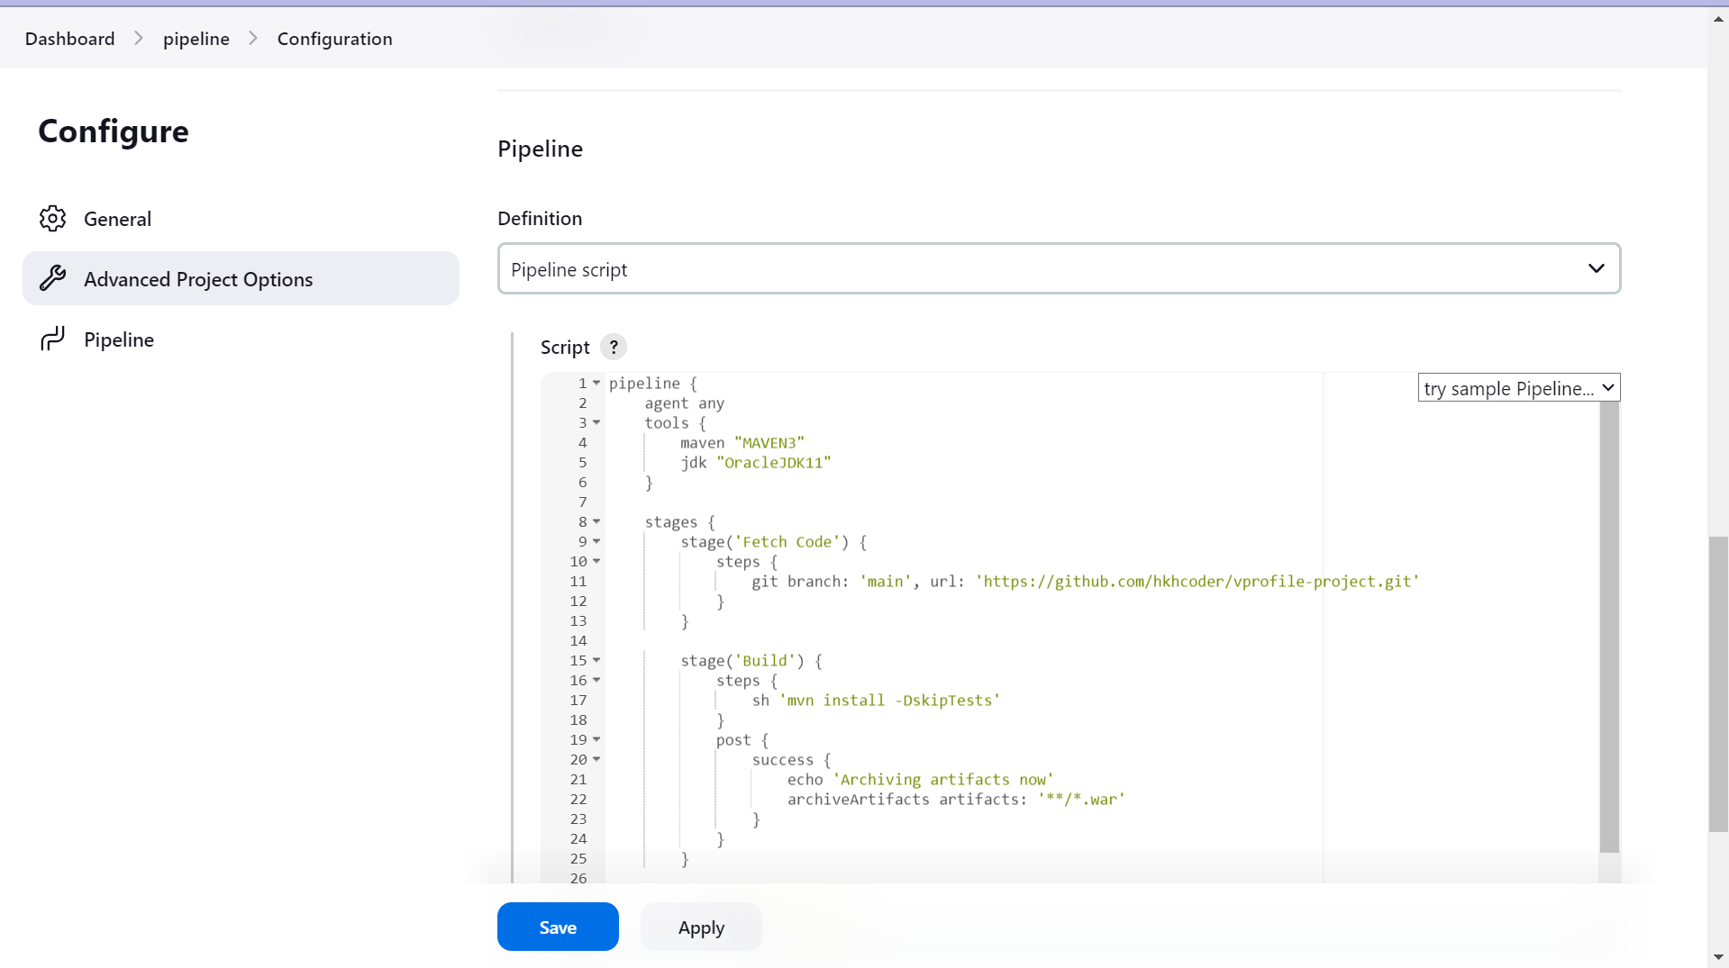

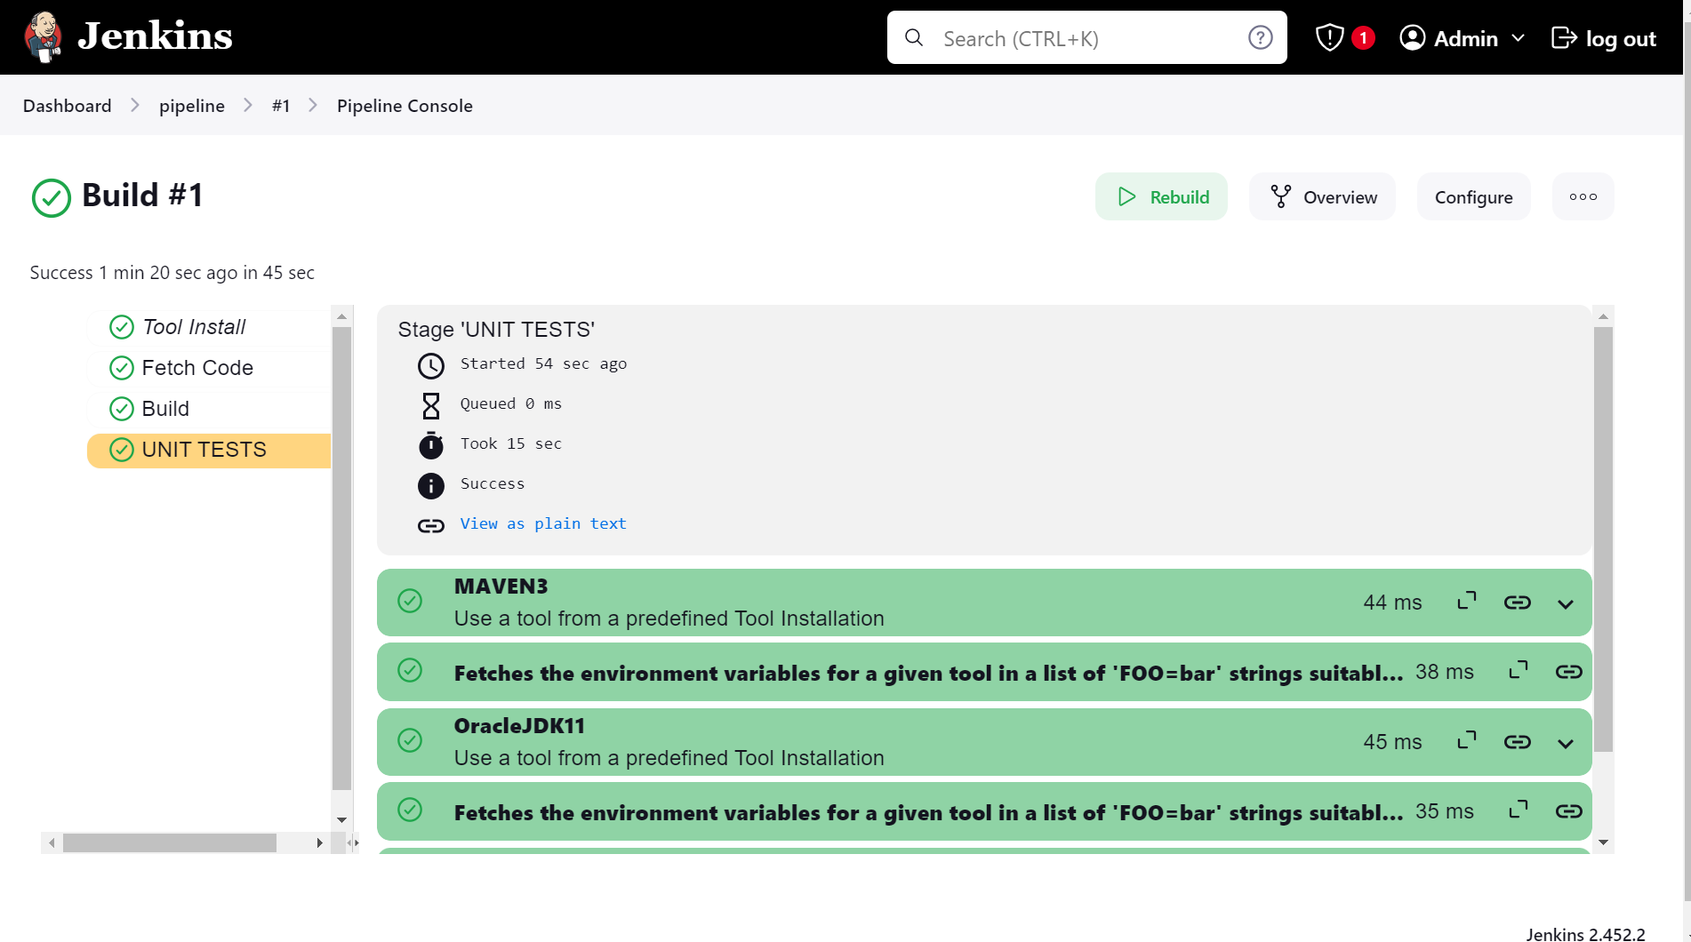

1. Code Analysis
   * + This is code testing.
     + It is done to detect vulnerability and functional error.
     + Top 10 Owasp Vulnerability :

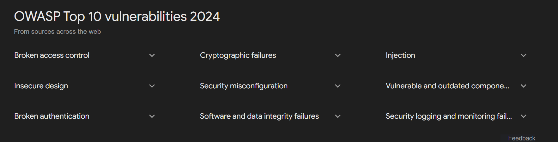

Why code analysis –

1. Best practices
2. Vulnerabilities in code
3. Functional error before deployment

Tools –

1. Checkstyle
2. Cobertura
3. Mstest
4. Owasp
5. SonarQube scanner

Integrating SonarQube scanner server with Jenkins :

* + - Install plugins for SonarQube

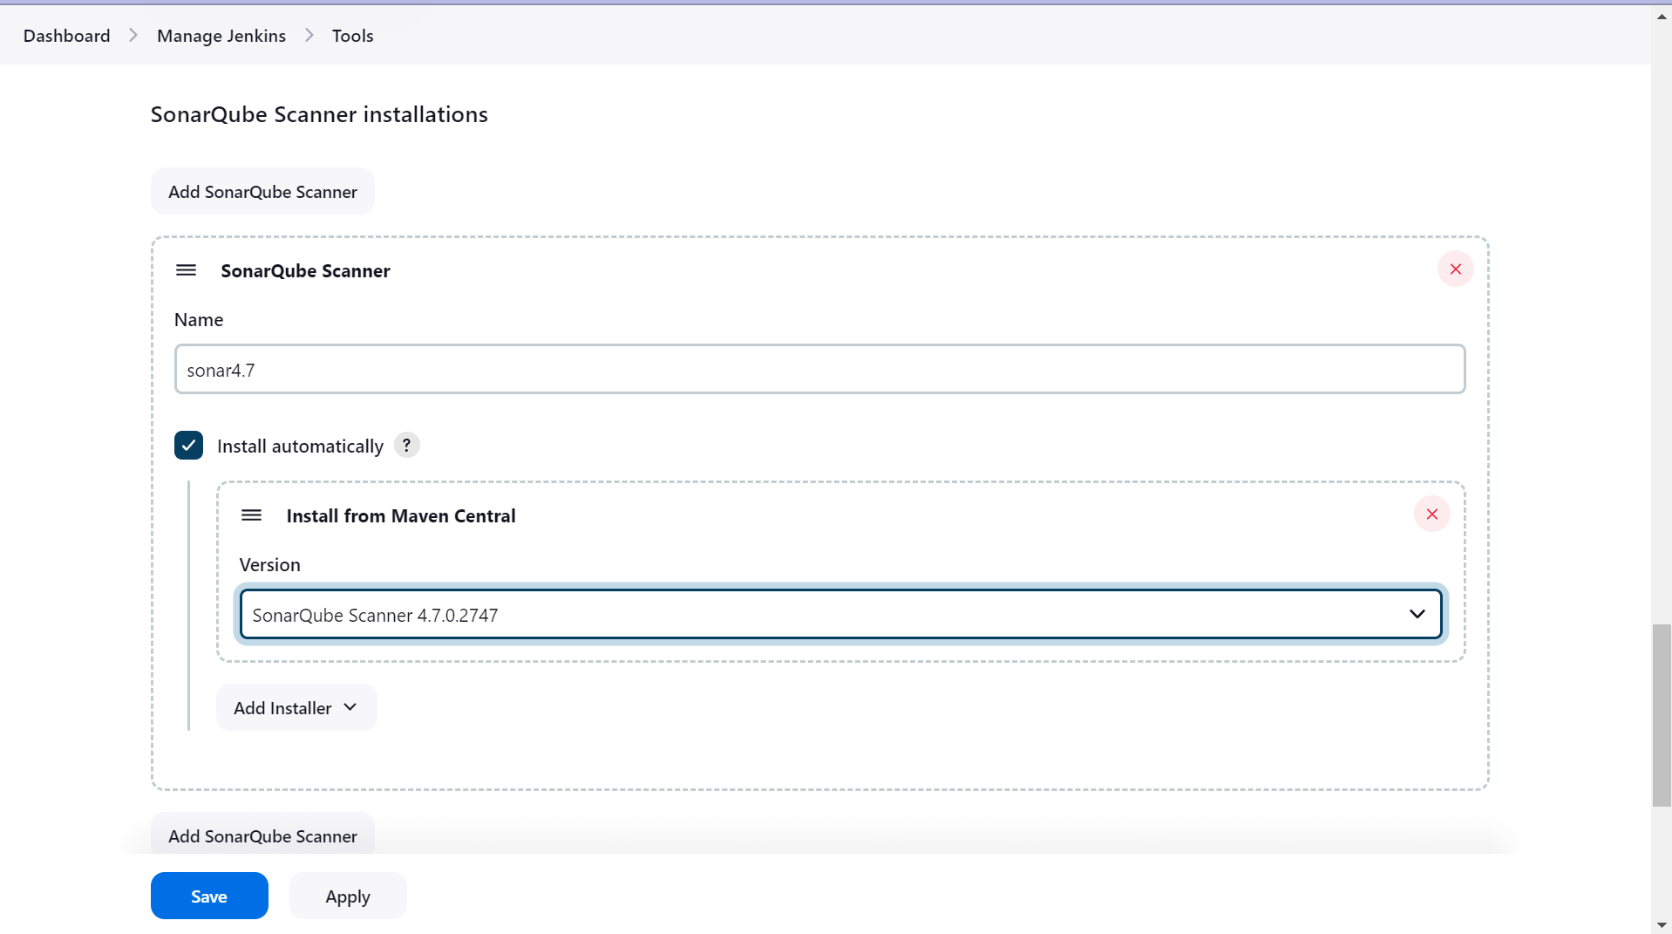

* + - Now go to Configure and check for sonarqube server

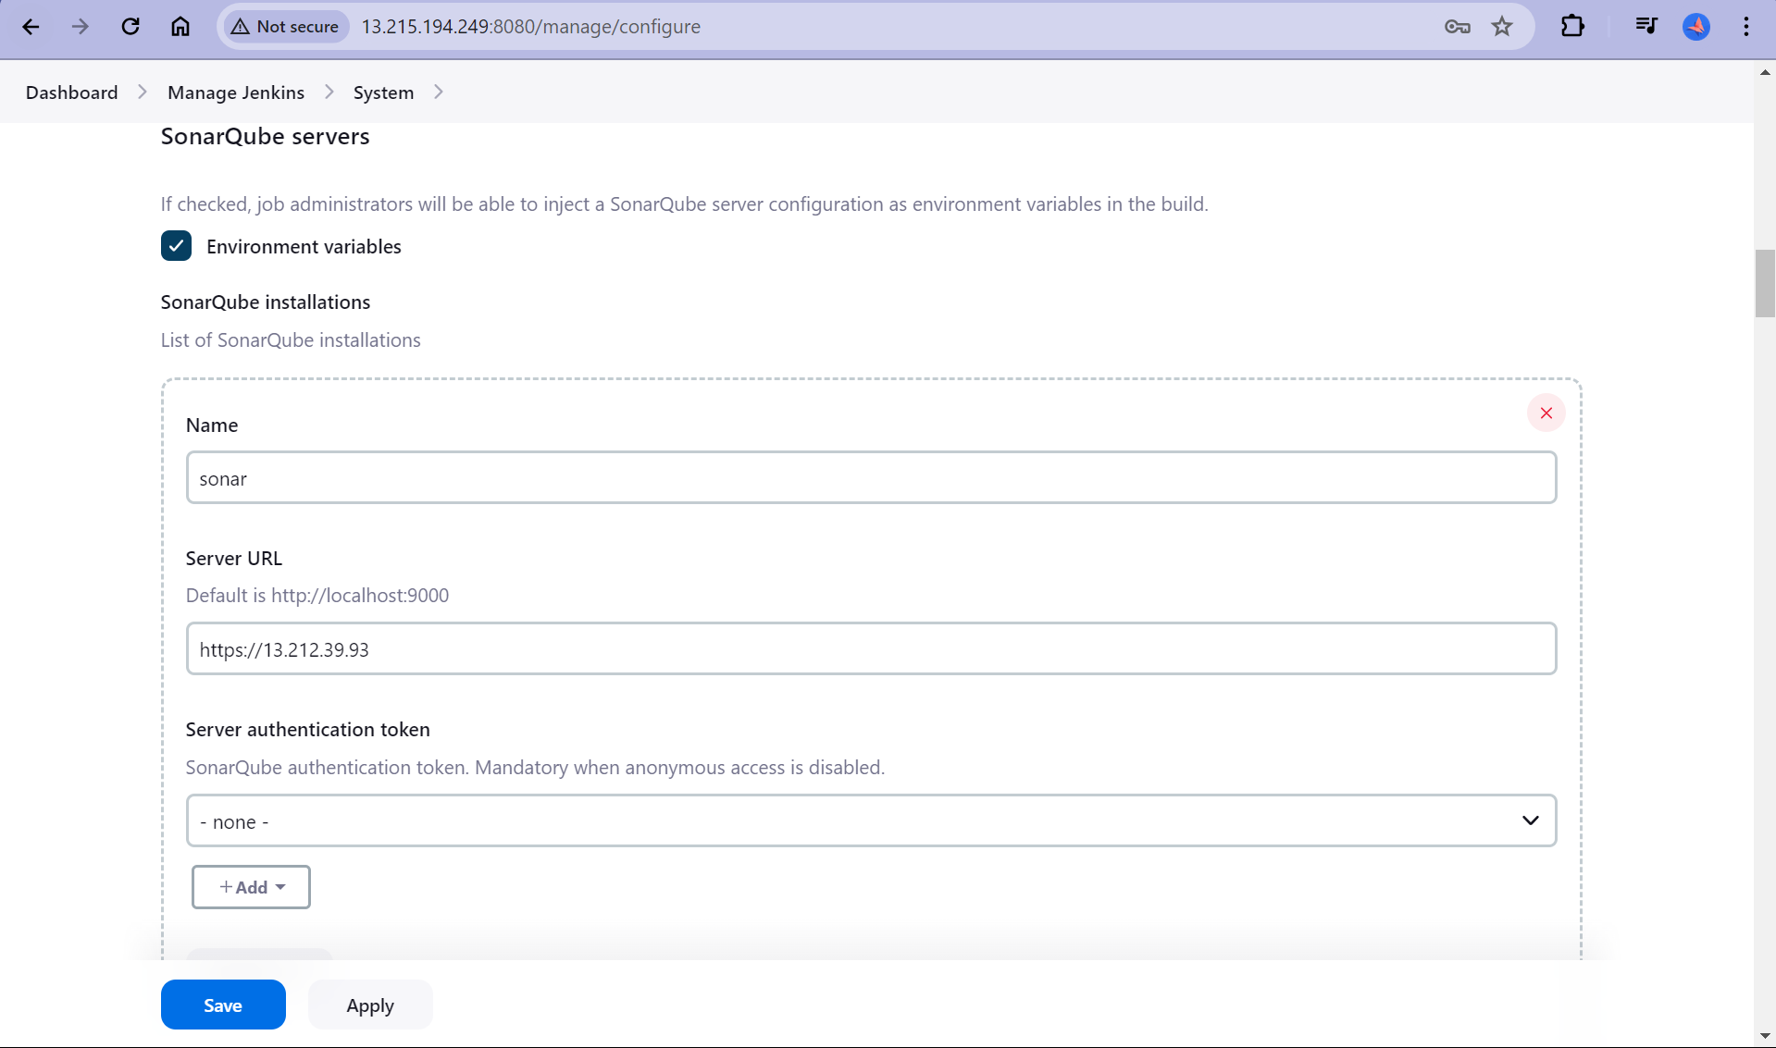

* + - Write code in your favourite editor

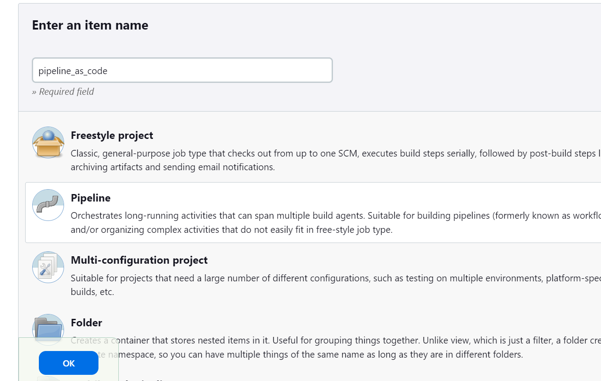

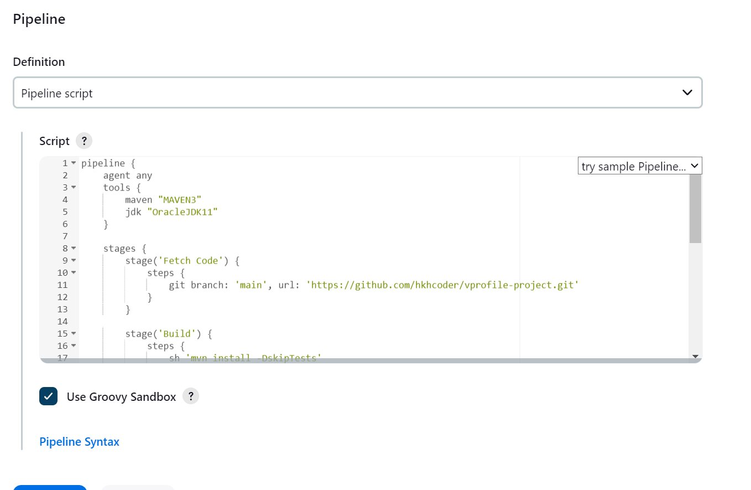

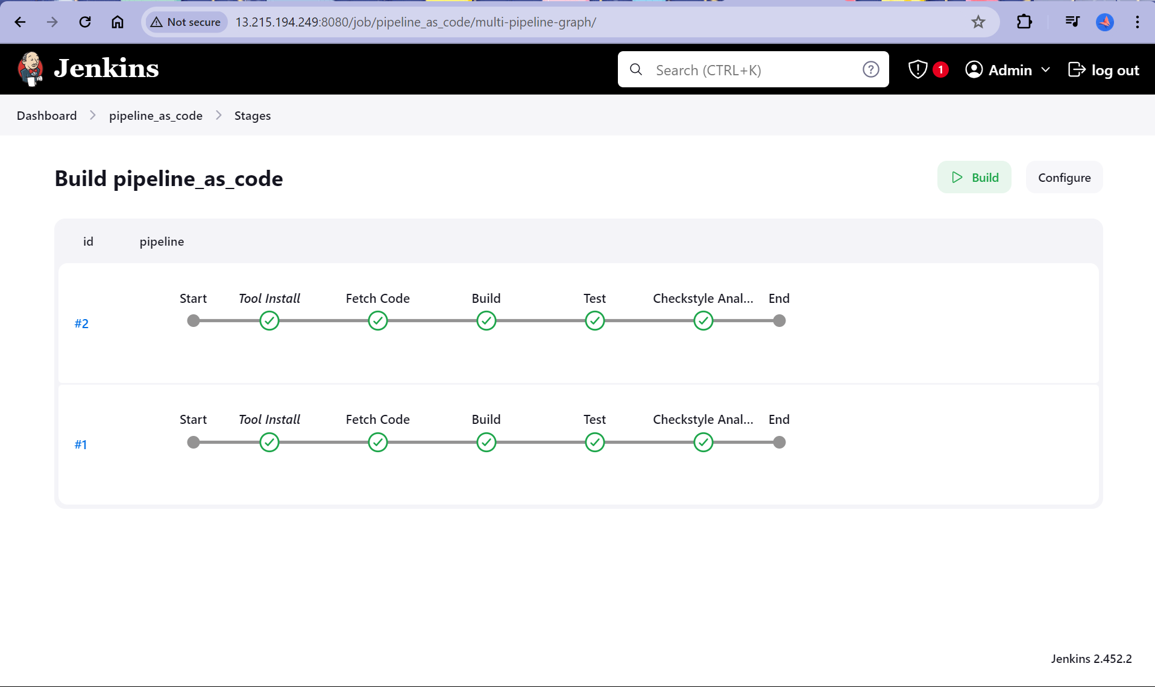

* + - Pipeline as code analysis with sonar

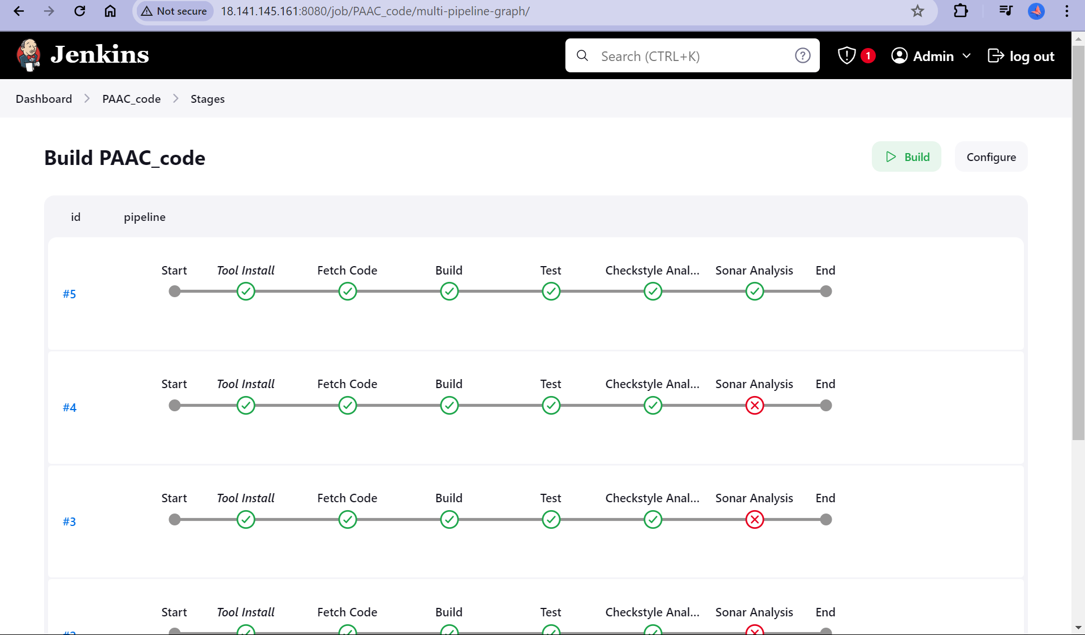

* + - View

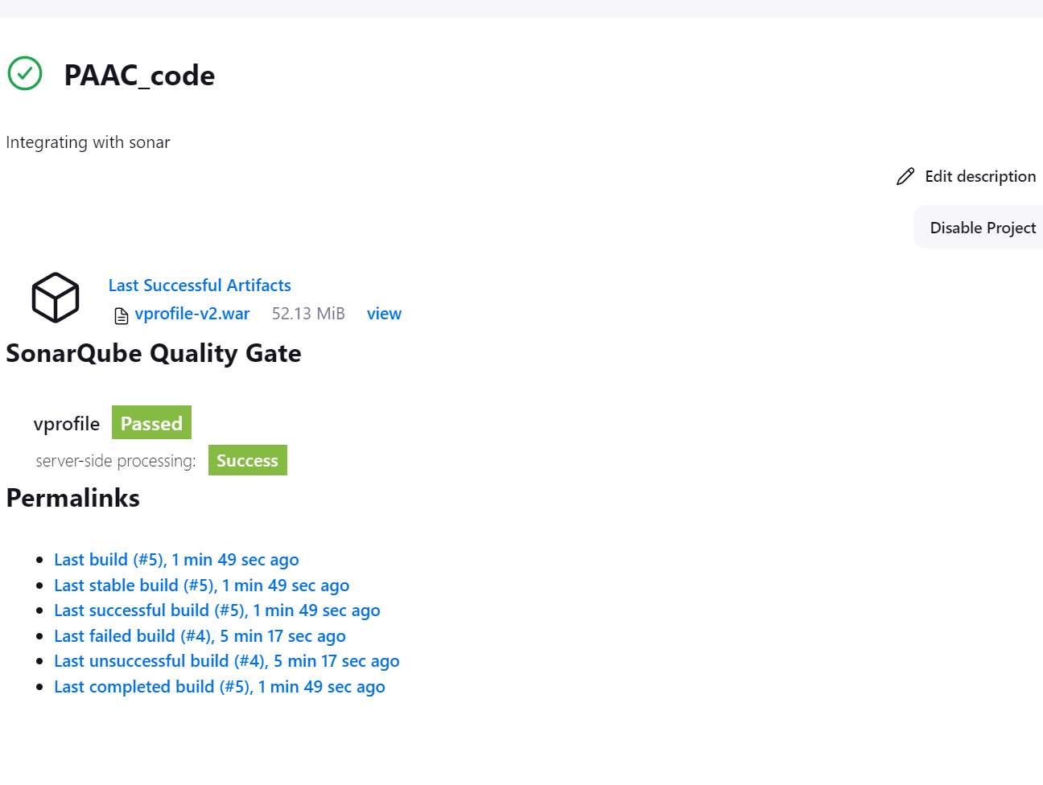

* + - SonarQube

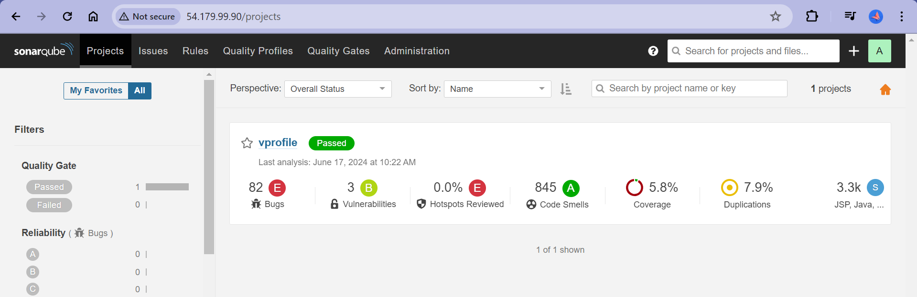

* + - Quality Gate

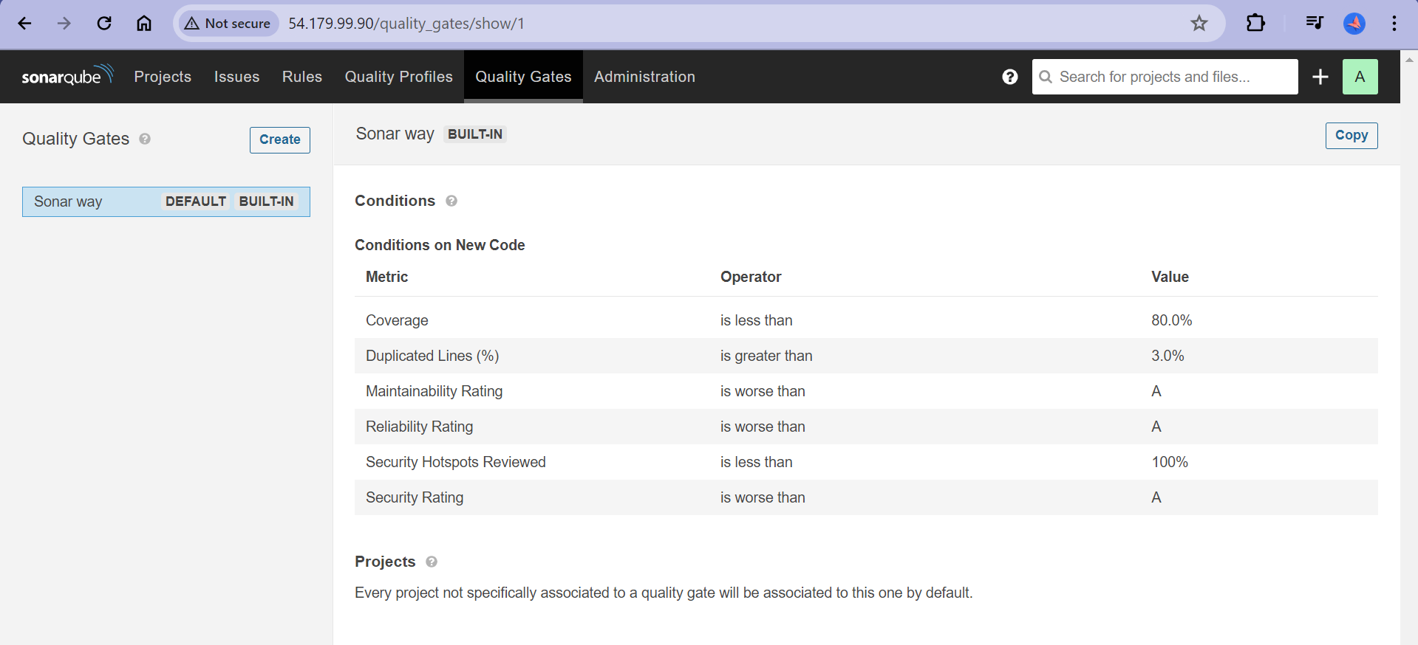

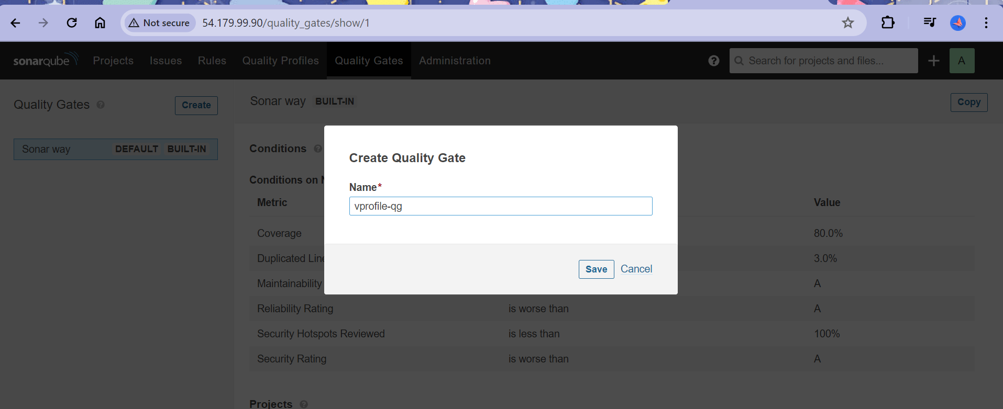

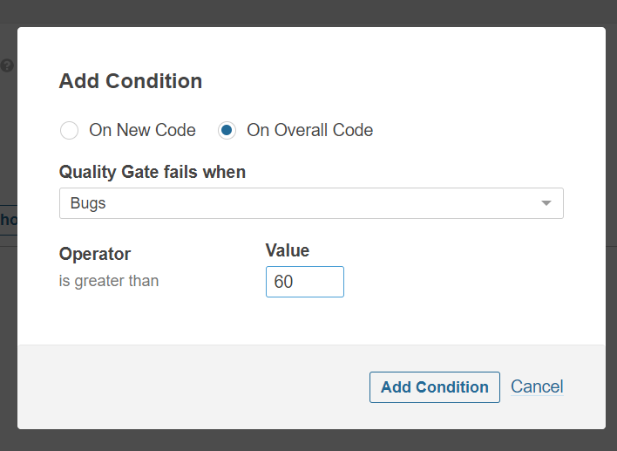

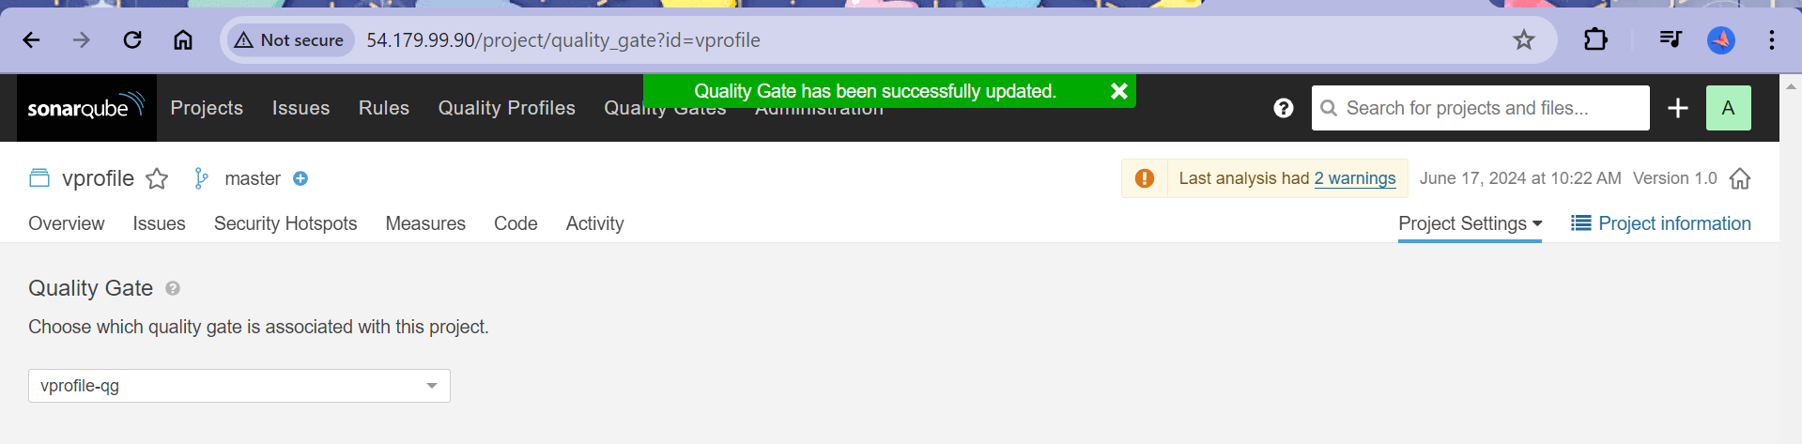

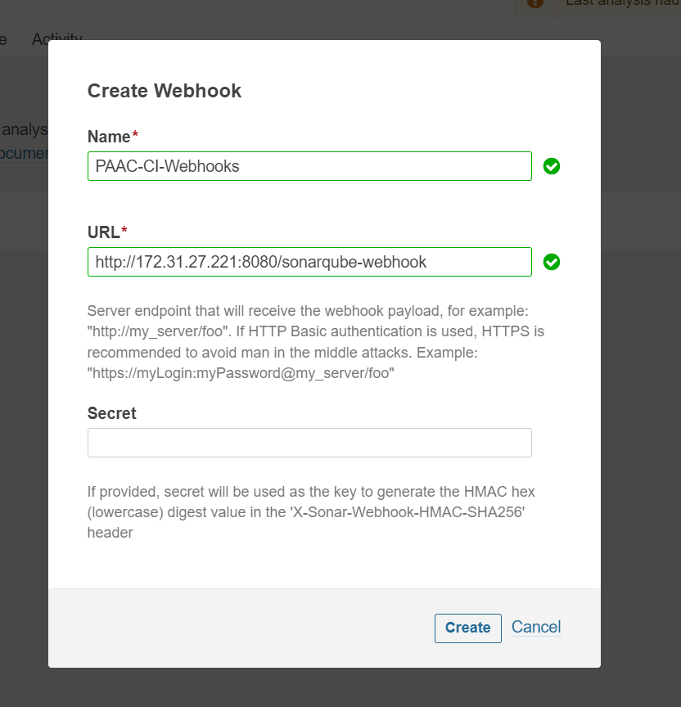

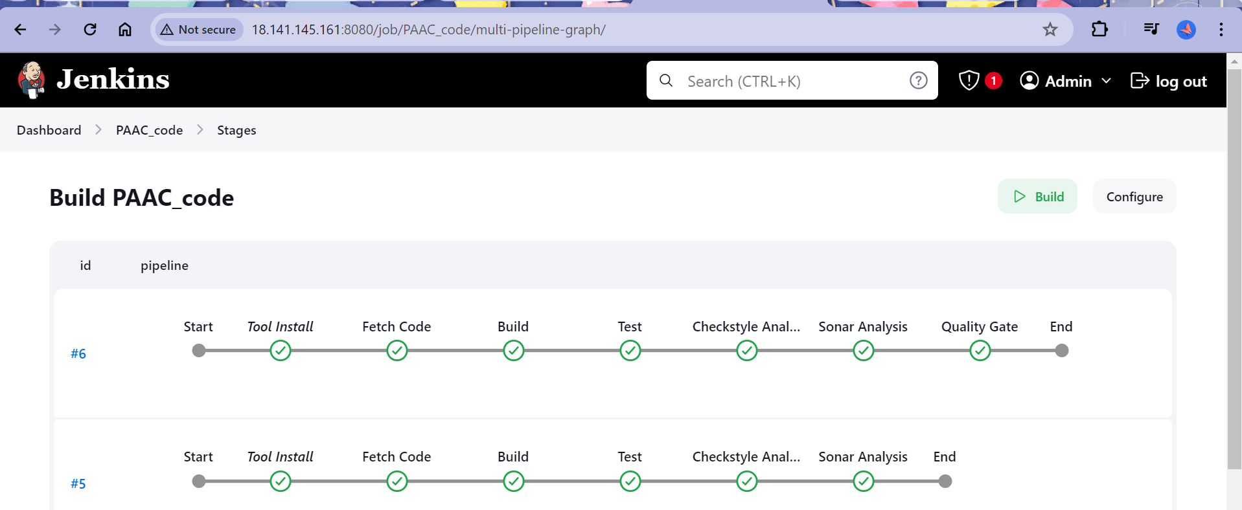

1. Upload Artifacts
   * + What exactly is nexus sona type repository?

Software repositories: Storage location for software packages

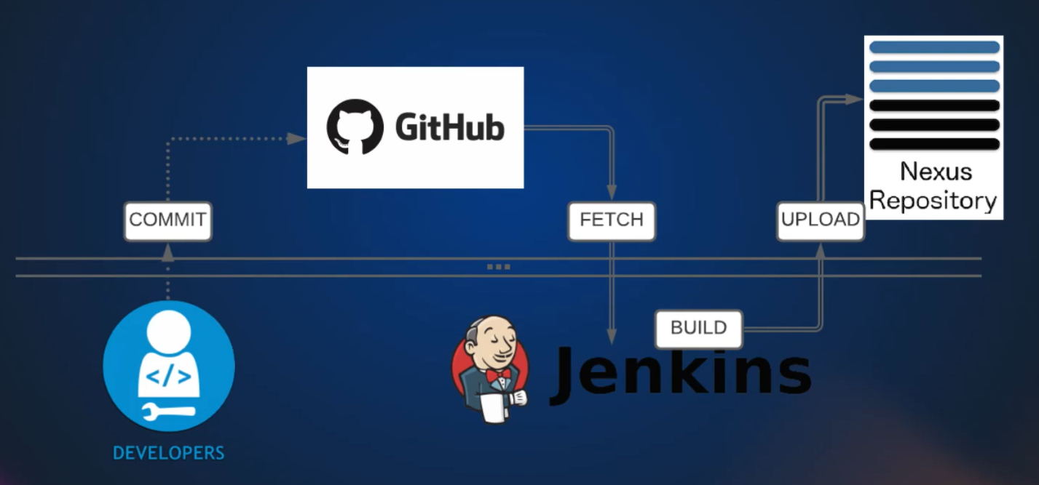

* + - Once artifacts are uploaded it is easily fetched by ops team for deployment.

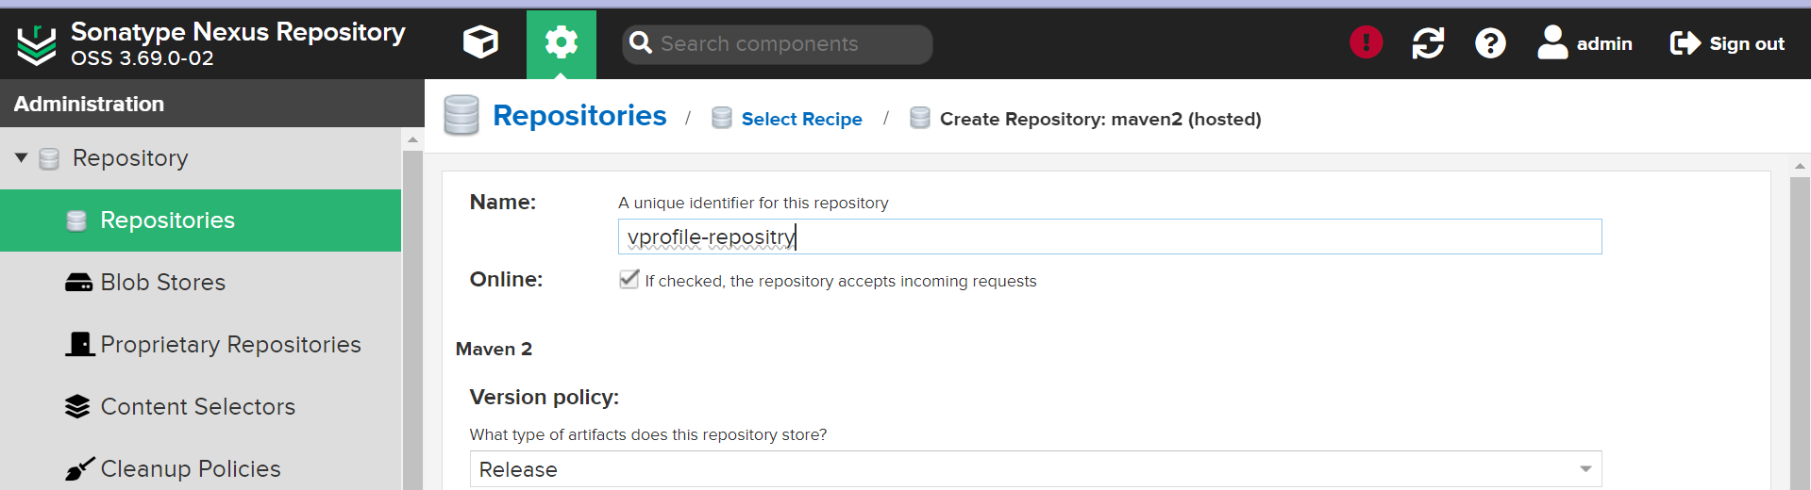

* + - Go to Jenkins and set credentials for nexus.

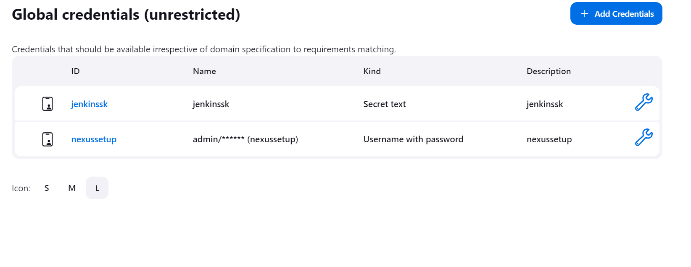

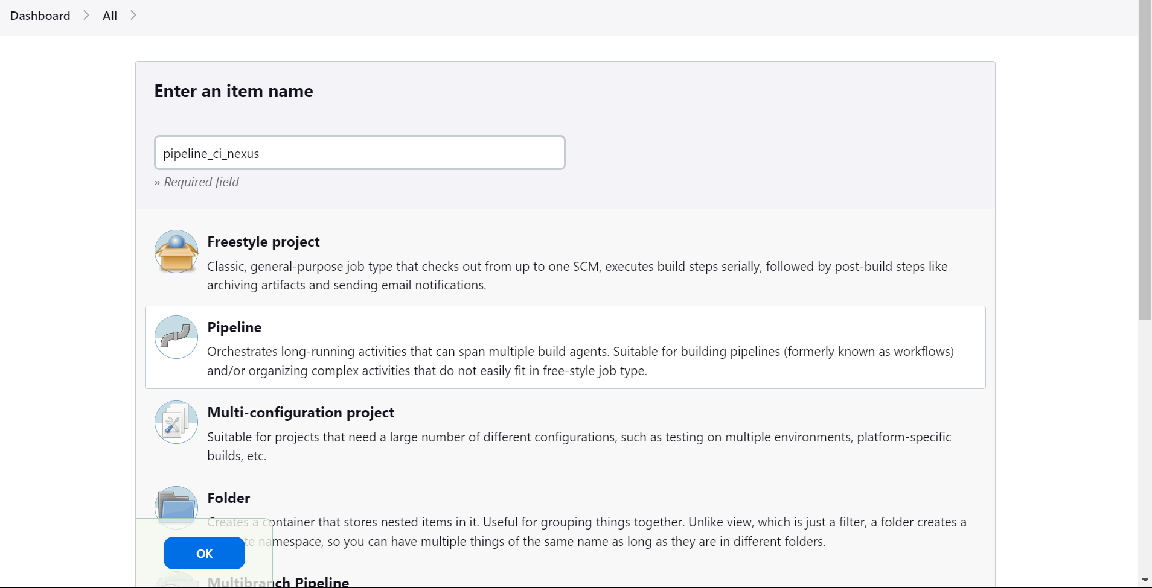

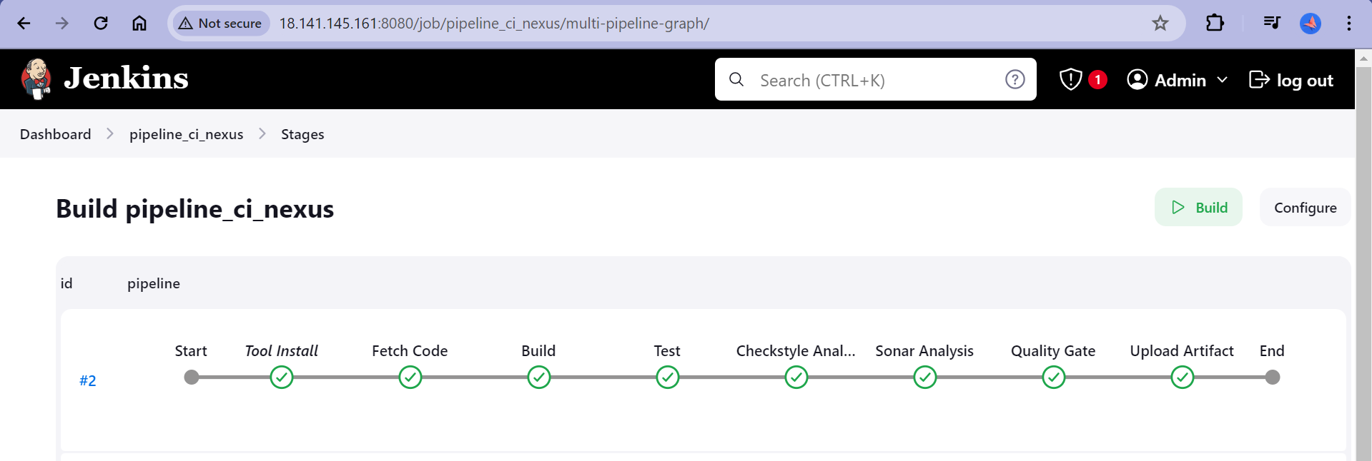

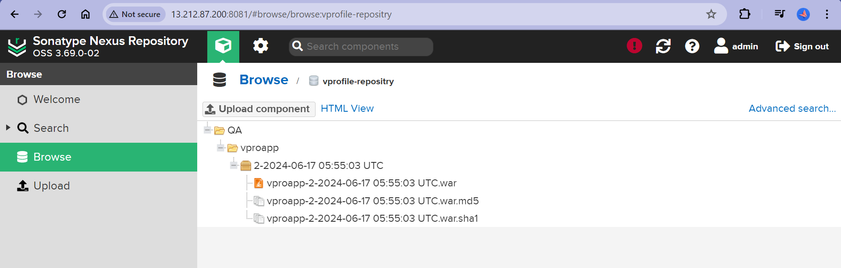

1. Upload Artifacts
   * + Notification for the pipeline is passed or failed.
     + We will be using the SLACK NOTIFICATION
     + Login to SLACK accounts

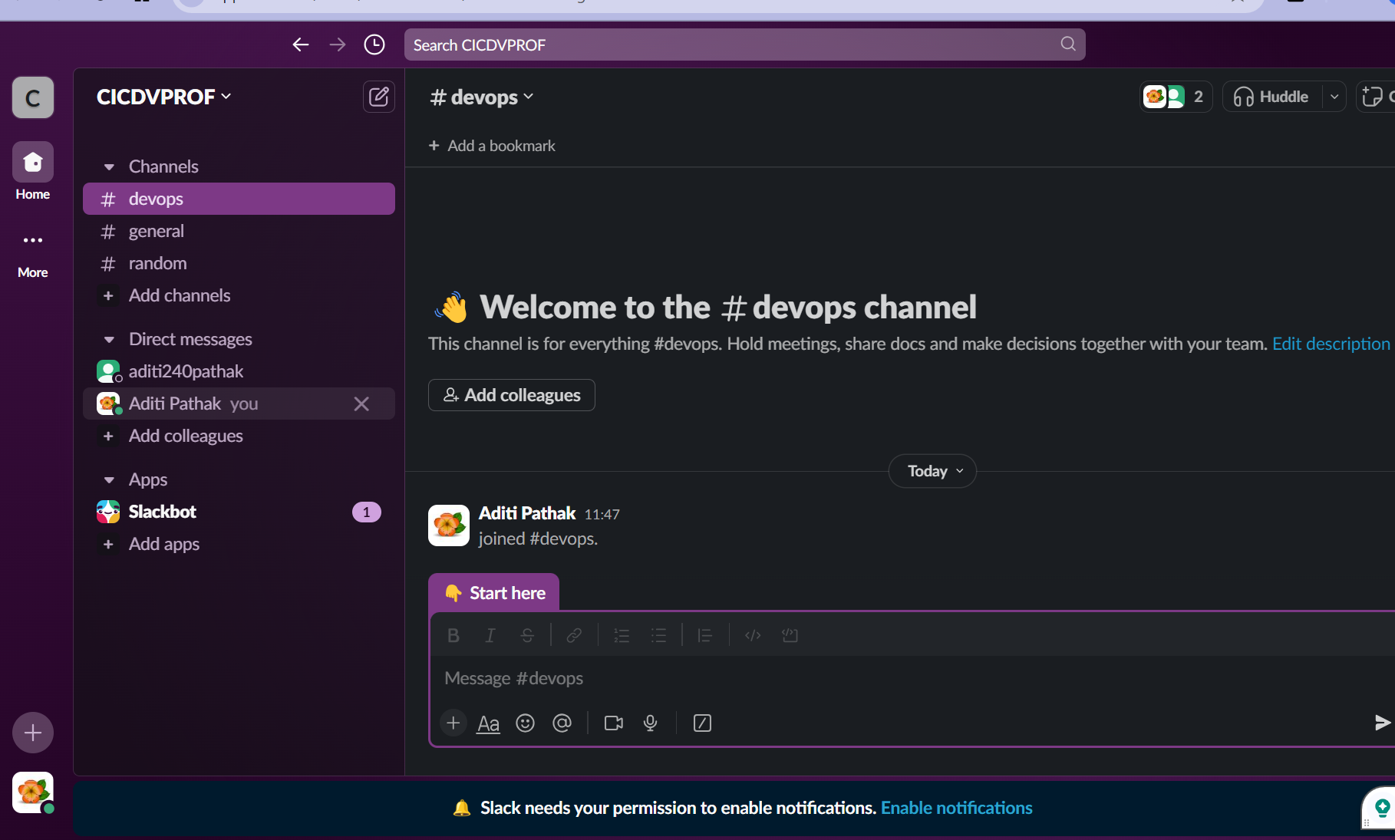

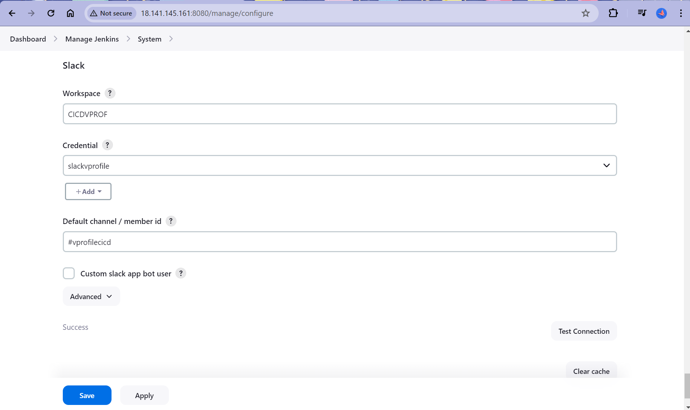

Let us add this information in pipeline code and build it in Jenkins

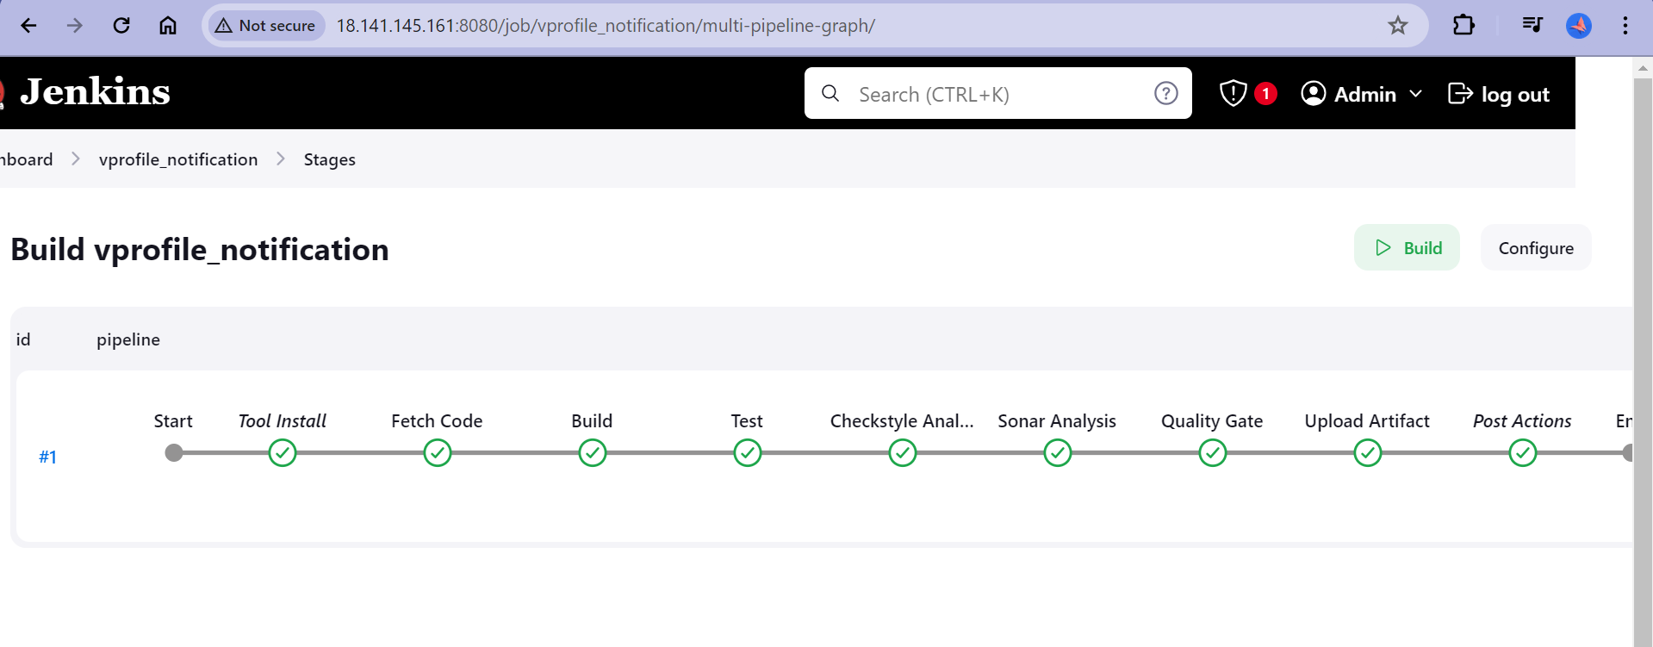

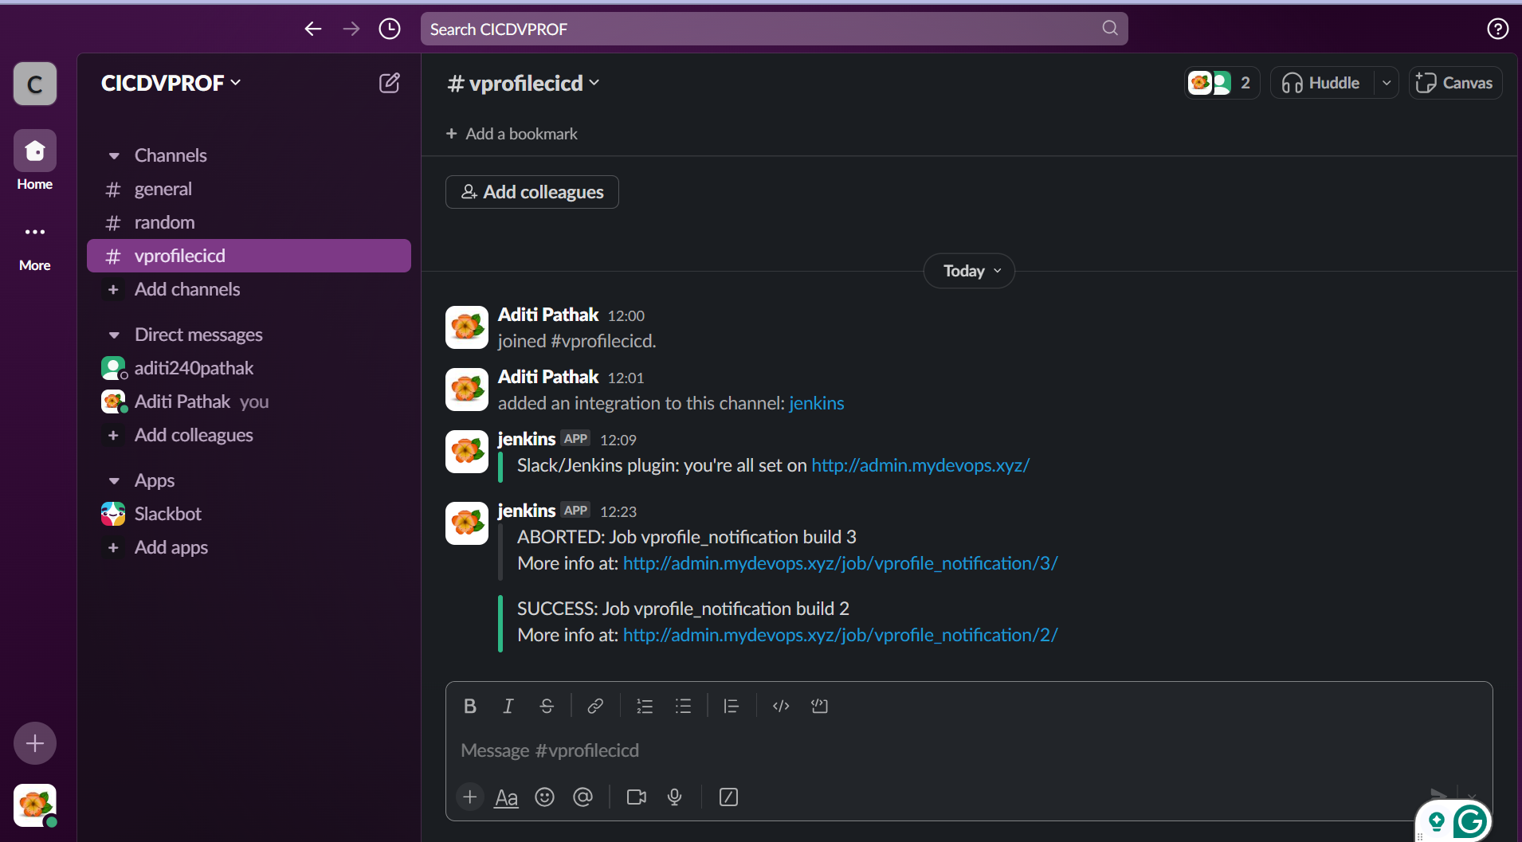

**All set ! Happy deploying ops team**